自得 | 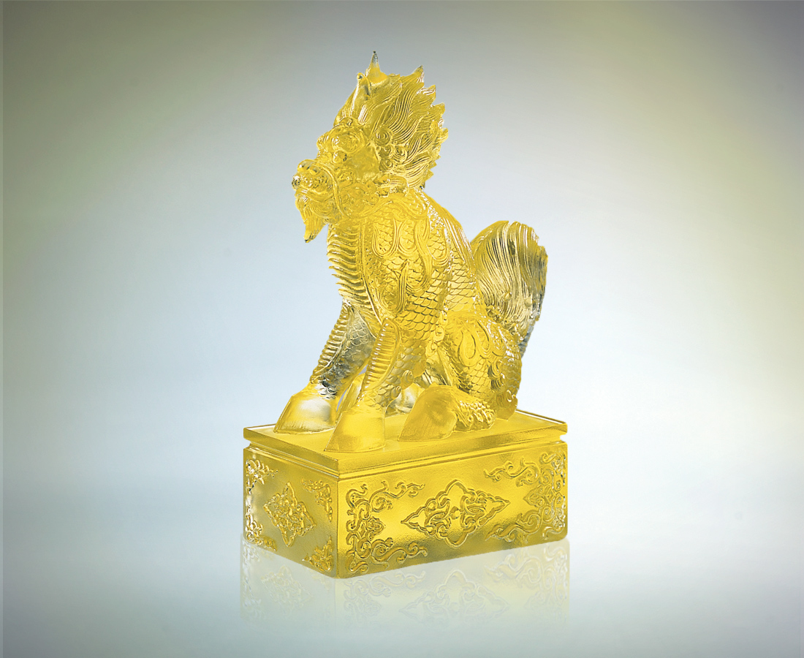
歷史啟示著
進化的本質 汰舊換新
人事的宿命 悲歡離合
眼前情節都將煙消雲散
台上人物不免得失沉浮
謹守正確的生命態度
盡忠本份 心安理得
飽嘗滄桑 笑看歷史
而怡然自得
Satisfaction
History tells us The essence of evolution is the succession of the old by the new The destiny of people is sadness, happiness, parting and meeting In the story before our eyes the smoke and clouds clear The actors on the stage can't avoid experiencing ups and downs Adhere to the correct attitude in life Do your bit Have an easy conscience Drink your fill of life's troubles Laugh at history But still be satisfied

編號 | 1507061 | No | 1507061
名稱 | 自得 | Name | Satisfaction
顏色 | 金 | Color
尺寸 | 12 * 7 * 19 | Size | 12 * 7 * 19
重量 | 1.9 | Weight | 1.9
限量 | O | Limited Edition | O
售價 | NT$ 16800 | Price | NT$ 16800
 | RMB$ 3788 |  | RMB$ 3788

