雙喜麟門 | 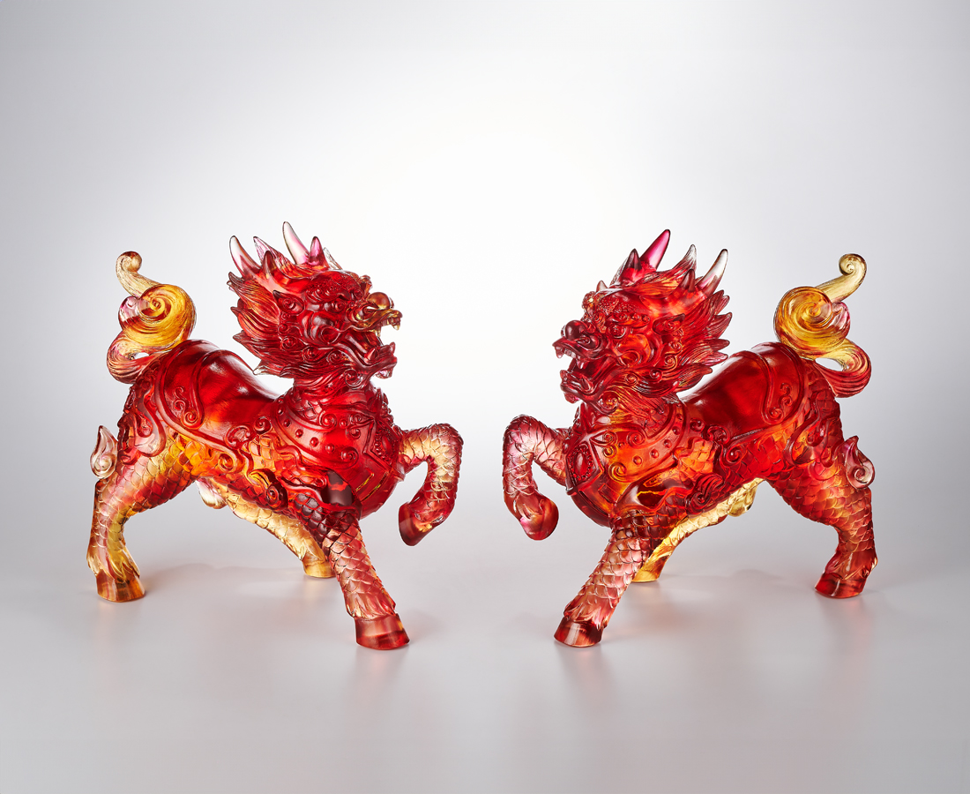
事好成雙成好事
春福迎喜迎福春
瑞顯光麟光顯瑞
花好進⾨進好花
Paired Qilin
The Qilin is a mythical creature in Chinese culture, resembling a blend of dragon and deer. Together with the phoenix, dragon, and tortoise, it is one of the "Four Auspicious Beasts," symbolizing auspiciousness. Known as the "Beast of Benevolence" for its gentle and caring nature, the Qilin is believed to bring peace and good fortune. When depicted in pairs with symmetrical poses, they symbolize protection and blessings for the home.

編號 | 1504134 | No | 1504134
名稱 | 雙喜麟門 | Name | Paired Qilin
顏色 | 琥紅透 | Color | amber, red, clear
尺寸 | 單隻約20 x 10.5 x 20 | Size | 單隻約20 x 10.5 x 20
重量 | 5.0 | Weight | 5.0
限量 | O | Limited Edition | O
售價 | NT$ 42800 | Price | NT$ 42800
 | RMB$ 9500 |  | RMB$ 9500

