有錢有銜 | 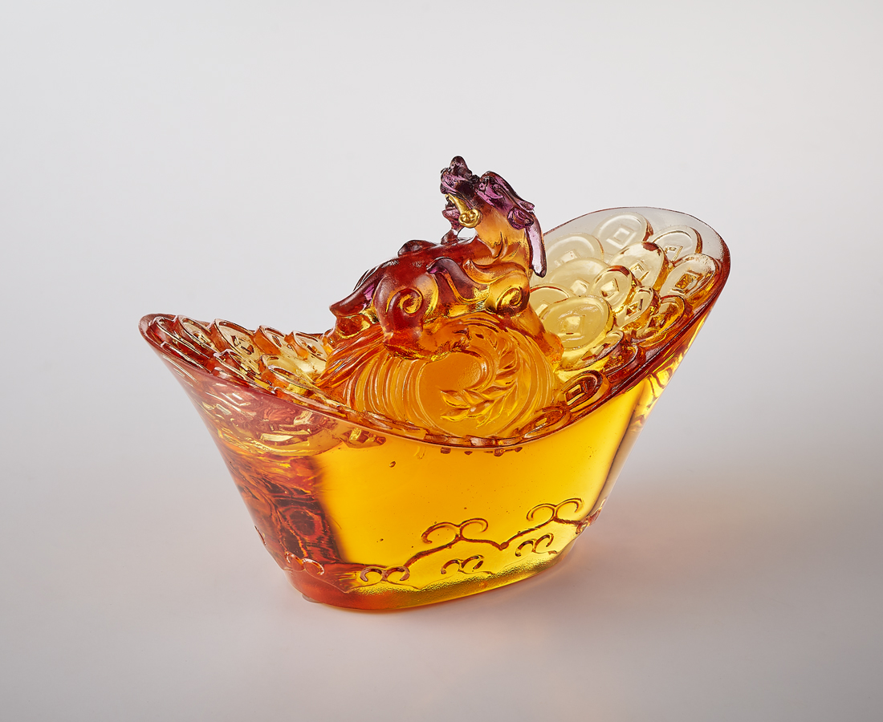
登臺展姿 風采自現傾眾目
財庫湧動 機遇緊銜轉瞬間
左右亨通 天下名傳
此刻 時來運轉
一生 有錢有閒
Wishing for Wealth: Pixiu on a Yuanbao
Standing on the "Yuanbao," an ancient form of Chinese currency, is the Pixiu, one of the most beloved mythical creatures in Chinese folklore. Renowned for attracting wealth, the Pixiu is depicted in a dynamic pose, biting onto a "Ruyi," a symbol of good fortune. This imagery suggests that it has seized the perfect opportunity, ensuring a continuous flow of abundant wealth.

編號 | 1504129 | No | 1504129
名稱 | 有錢有銜 | Name | Wishing for Wealth: Pixiu on a Yuanbao
顏色 | 金琥紫+金箔 | Color | Gold, amber, purple + gilding
尺寸 | 13.5 x 6.6 x 9.5 | Size | 13.5 x 6.6 x 9.5
重量 | 0.69 | Weight | 0.69
限量 | X | Limited Edition | X
售價 | NT$ 7200 | Price | NT$ 7200
 | RMB$ 1600 |  | RMB$ 1600

