創大業 | 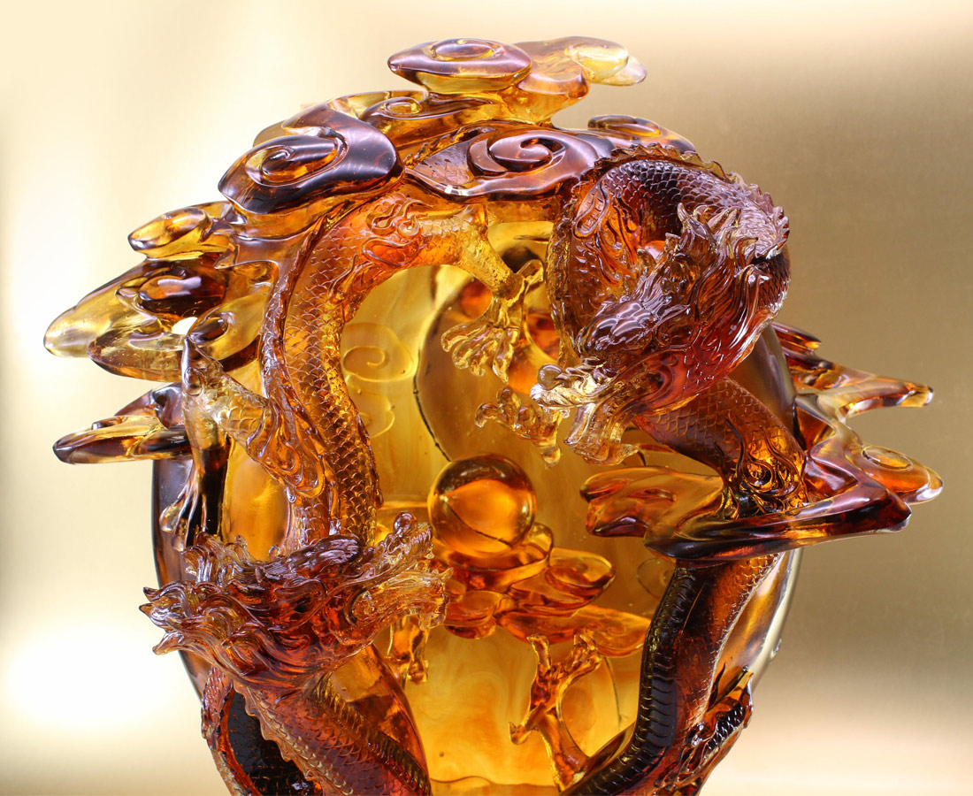
胸懷膽識 上天入地
雙龍探珠 亦競亦合
競 激出智勇 爭得頭籌
合 廣集群力 更創新局
競合中 共存亦共榮
Double Dragons
The artwork, with the image of sunshine glazing out the layers of clouds, presents a “beginning of the universe” scene. By alternating Yin and Yang carving, the work depicts the mysterious speed of the dragons. The scene of two dragons fighting for a pearl indicates the spirit of competing while cooperating. Competition grants birth of intelligence and courage, and cooperation produces the strength as a whole.

編號 | 1503887 | No | 1503887
名稱 | 創大業 | Name | Double Dragons
顏色 | 金琥茶透 | Color | golden, amber, brown, clear
尺寸 | 45 * 36 * 52 | Size | 45 * 36 * 52
重量 | 31.0 | Weight | 31.0
限量 | O | Limited Edition | O
售價 | NT$ 388000 | Price | NT$ 388000
 | RMB$ 86250 |  | RMB$ 86250

