氣宇軒昂 | 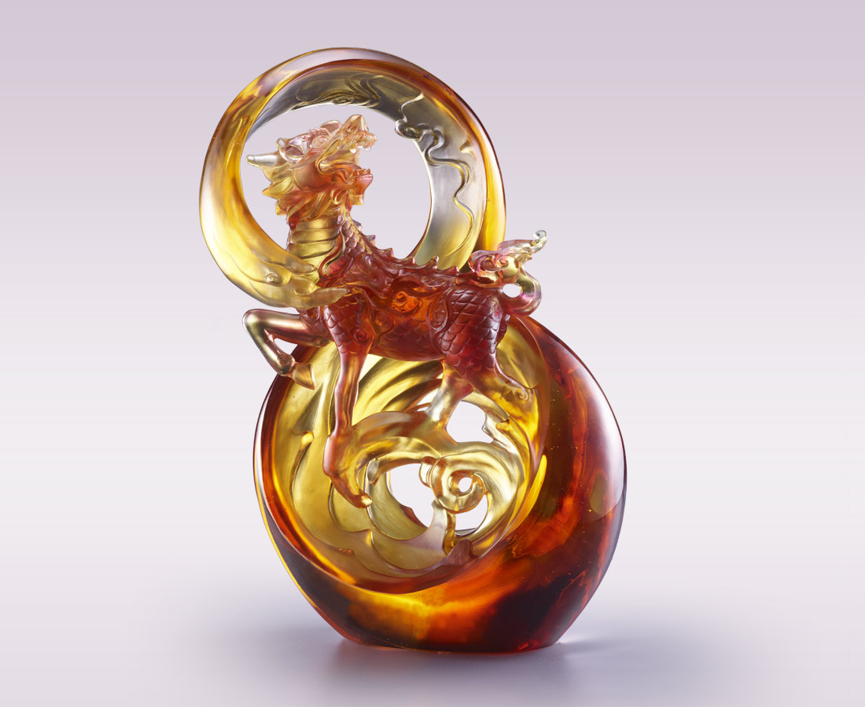
極目遠眺 氣宇軒昂
掌握大局 不拘小節
看八荒風雲 陰晴圓缺
存四海心境 悲歡離合
以吉祥之氣御運勢
以慈悲之心降眾生
無往不利
無願不還
The Qilin
The artwork utilizes the Qilin and the shape of digit 8 as the main subject. The Qilin, gazing back, depicts mercy and benevolence. The shape of digit 8 on the other hand is similar to the infinity symbol, indicating the rule of universe. In overall, the artwork conveys the landing of Qilin on Earth, looking after the Earth with benevolence.

編號 | 1503885 | No | 1503885
名稱 | 氣宇軒昂 | Name | The Qilin
顏色 | 紅琥透 | Color | red, amber, clear
尺寸 | 20 * 13 * 29.8 | Size | 20 * 13 * 29.8
重量 | 4.9 | Weight | 4.9
限量 | O | Limited Edition | O
售價 | NT$ 50350 | Price | NT$ 50350
 | RMB$ 11200 |  | RMB$ 11200

