獨占鰲頭 | 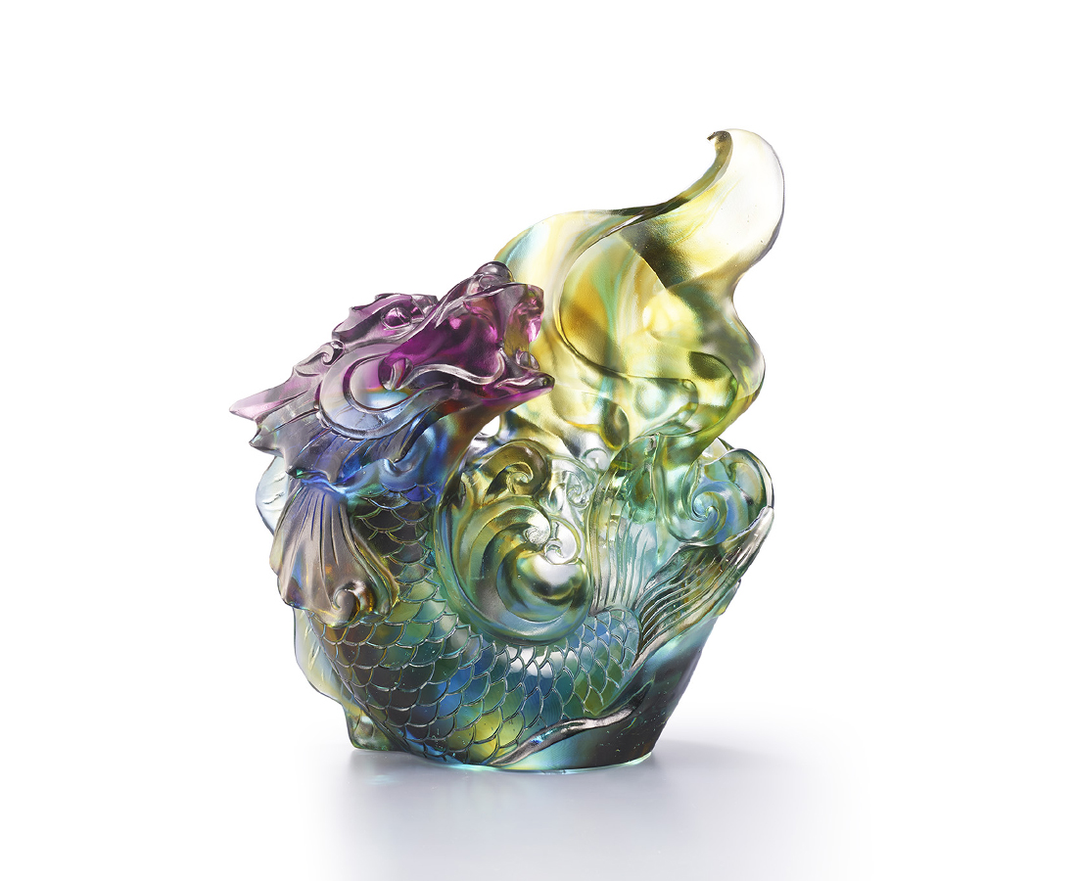
赤膽忠信
我遙望前程無比絢麗
雖山嶂重巒 嘲諷霧霾
今日跌宕 換作明日華章
義無反顧
千折百撓也須堅持到底
雖威迫利誘 窮且不明
幾番風雨 更待來日豐碑
莫遲疑 勿迷失
鰲頭終得躍龍門 再做新人間
Soft-shell Turtle
The soft-shell turtle, or the “Bie” Fish in Chinese culture, has the head of a dragon and body of a carp. It is said that the reptile likes to swallow fire, thus often appearing on wooden houses, expressing protection from fire. Due to its unique body structure, there was a legend of it jumping over the dragon’s gate, symbolizing hard work guarantees success.

編號 | 1503883 | No | 1503883
名稱 | 獨占鰲頭 | Name | Soft-shell Turtle
顏色 | 藍青紫琥透 / 紅金透 | Color | blue, cyan, purple, amber, clear / red,
尺寸 | 18.8 * 11.2 * 21.8 | Size | 18.8 * 11.2 * 21.8
重量 | 3.5 | Weight | 3.5
限量 | O | Limited Edition | O
售價 | NT$ 31800 | Price | NT$ 31800
 | RMB$ 7080 |  | RMB$ 7080

