大展乾坤 | 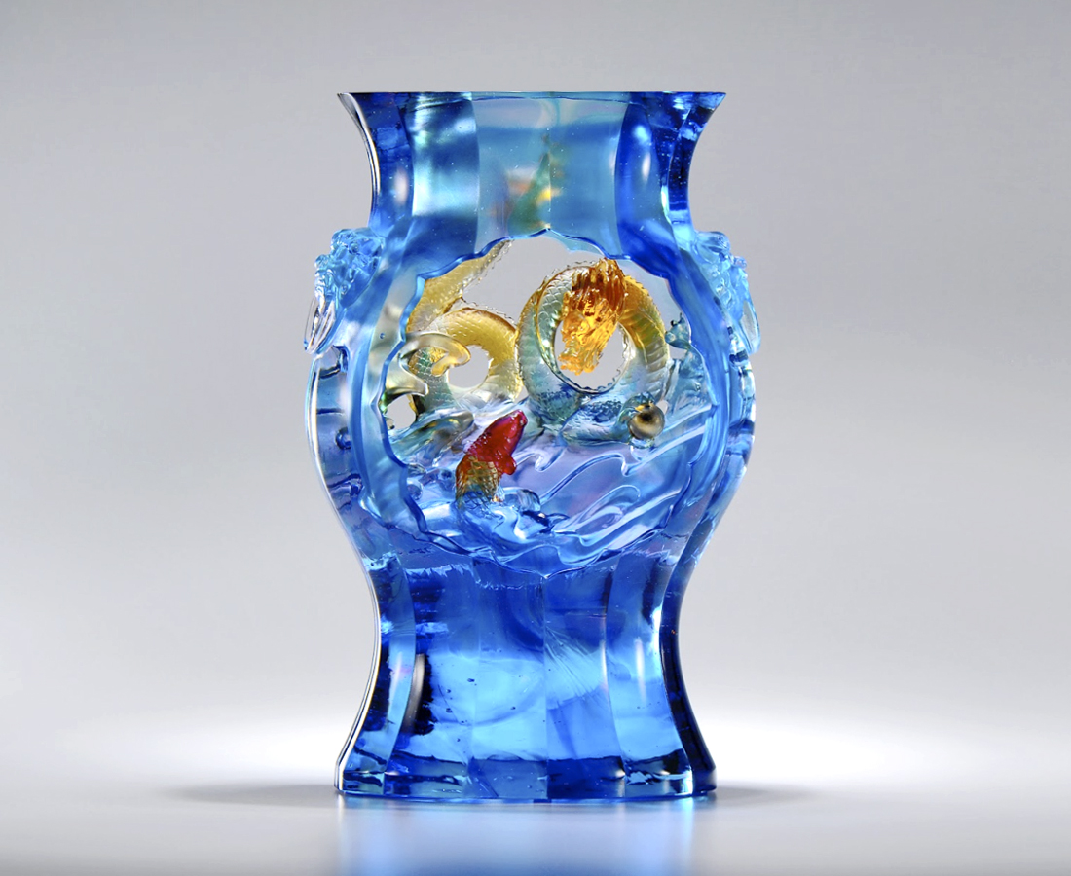
矯捷身手
風裡來 水裡去
左右合拍
通天地 觀古今
吐納浩然英雄氣
乘勢大展乾坤身手
Dragon Improving from Fish
In Chinese culture, the transformation from fish to dragon symbolizes to be successful. Our designer uses an artifact from the National Palace Museum of Taiwan, the Green-ground Floral-shaped Vase with Fish-Dragon Motif, as this artwork’s framework, altering the originally 2D design into a 3D relief. Within the artwork illustrates the movements of the fish and dragon, symbolizing one’s success comes from being able to seize his/her chance.

編號 | 1503882 | No | 1503882
名稱 | 大展乾坤 | Name | Dragon Improving from Fish
顏色 | 藍青紫紅琥透+金箔 | Color | blue, cyan, purple, red, amber, clear +
尺寸 | 18.2 * 10 * 28.2 | Size | 18.2 * 10 * 28.2
重量 | 6.4 | Weight | 6.4
限量 | O | Limited Edition | O
售價 | NT$ 56500 | Price | NT$ 56500
 | RMB$ 12550 |  | RMB$ 12550

