平安有餘 | 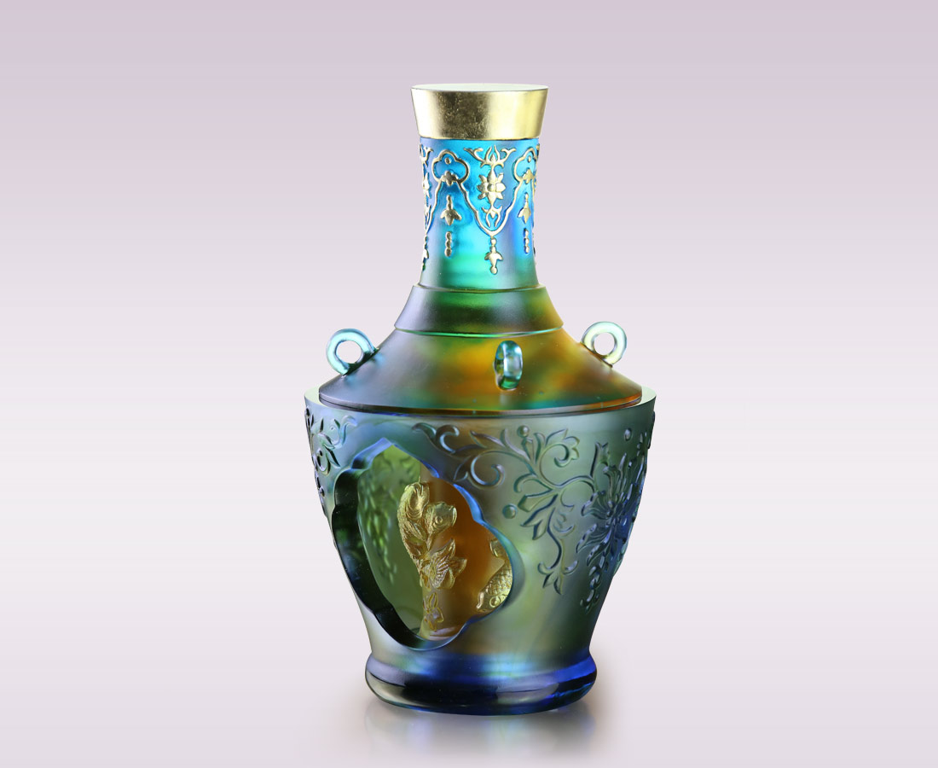
轉得瀟灑
窗外即是好風景
轉動心念
又是柳暗花明
一身悠然有餘
一生平安如意
Revolving Vase with Swimming Fish Decoration
Tittot redefines the artifact from the National Palace Museum of Taiwan named as the title with the use of glass art. From the clear glass finds you the relief of swimming fish, showing different feelings from porcelain. In Chinese culture, fish represents abundance. With the skill of engraving, this artwork demonstrates blessings of abundance of happiness.

編號 | 1503881 | No | 1503881
名稱 | 平安有餘 | Name | Revolving Vase with Swimming Fish Decoration
顏色 | 藍青琥綠透+金箔 | Color | blue, cyan, amber, green, clear + gildi
尺寸 | 13.5 * 13.5 * 24 | Size | 13.5 * 13.5 * 24
重量 | 2.7 | Weight | 2.7
限量 | O | Limited Edition | O
售價 | NT$ 42800 | Price | NT$ 42800
 | RMB$ 9500 |  | RMB$ 9500

