天祿轉運 | 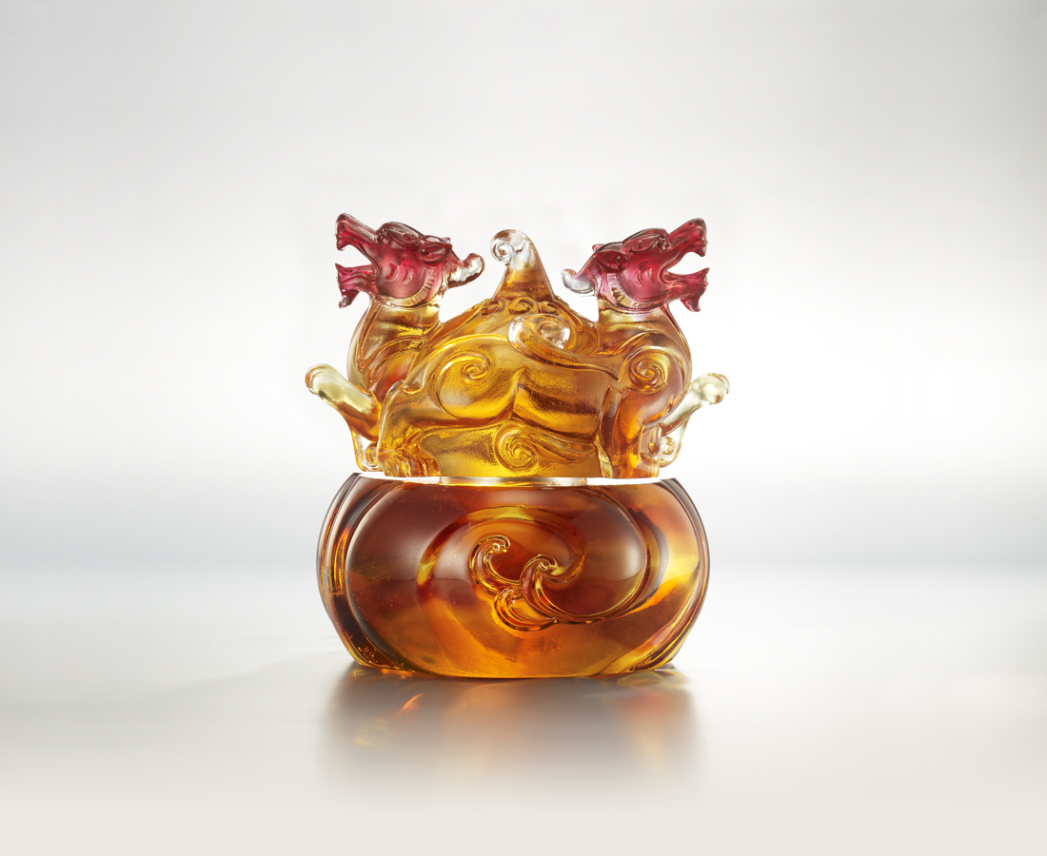
翻湧不已的波濤
是千軍萬馬的信心
義無反顧 一無所懼
轉動觸手可及的機運
坐擁源源天賜的福祿
The Pixiu Gourd
The Pixiu is a Chinese mythical creature that protects wealth and brings fortune. In this artwork, the two rotatable Pixius sit on a wealth-filling gourd, as the Pixius brings blessings from all sides whilst protecting the owner’s money.

編號 | 1503866 | No | 1503866
名稱 | 天祿轉運 | Name | The Pixiu Gourd
顏色 | 琥紅透 | Color | amber, red, clear
尺寸 | 14 * 14 * 15 | Size | 14 * 14 * 15
重量 | 3.6 | Weight | 3.6
限量 | O | Limited Edition | O
售價 | NT$ 25780 | Price | NT$ 25780
 | RMB$ 5750 |  | RMB$ 5750

