極致風光 | 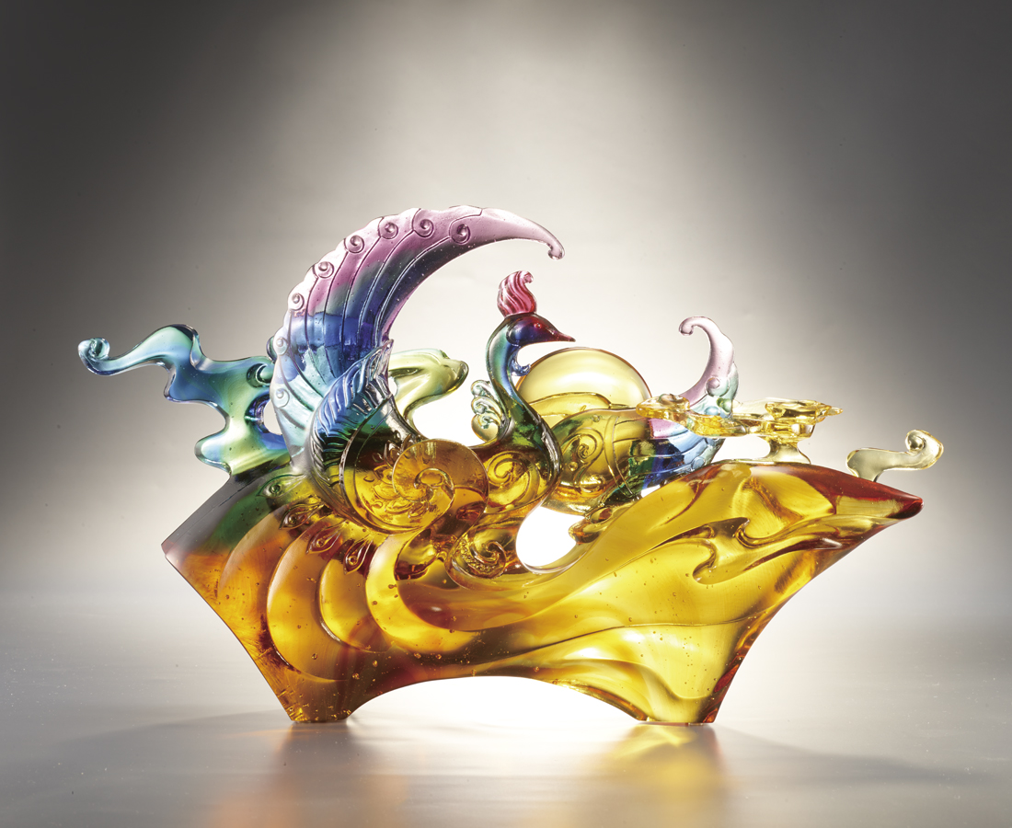
浴火而生 昂首高鳴
從四方堂堂而起
捲起如風似火的熱情
展開橫貫古今的大翼
掃除重重雲霧
俯瞰五湖四海
以脫穎而出的光與彩
引領千百年的極致風光
The Dancing Phoenix
Phoenix, in Chinese Culture, symbolizes a coming of new era. Tittot applies a brand-new polishing technique, involving difference between the work’s and its stand’s thickness. This technique depicts a Phoenix dancing in colored clouds, while color and light flows through the entire artwork. Tittot hopes this work, like Phoenix, symbolizes coming of glass art’s new era.

編號 | 1503852 | No | 1503852
名稱 | 極致風光 | Name | The Dancing Phoenix
顏色 | 藍綠紅紫琥透 | Color | blue, green,red, purple, amber, clear
尺寸 | 37.7 * 9 * 23.7﻿ | Size | 37.7 * 9 * 23.7﻿
重量 | 5.5 | Weight | 5.5
限量 | O | Limited Edition | O
售價 | NT$ 49800 | Price | NT$ 49800
 | RMB$ 11100 |  | RMB$ 11100

