宜祿如意 | 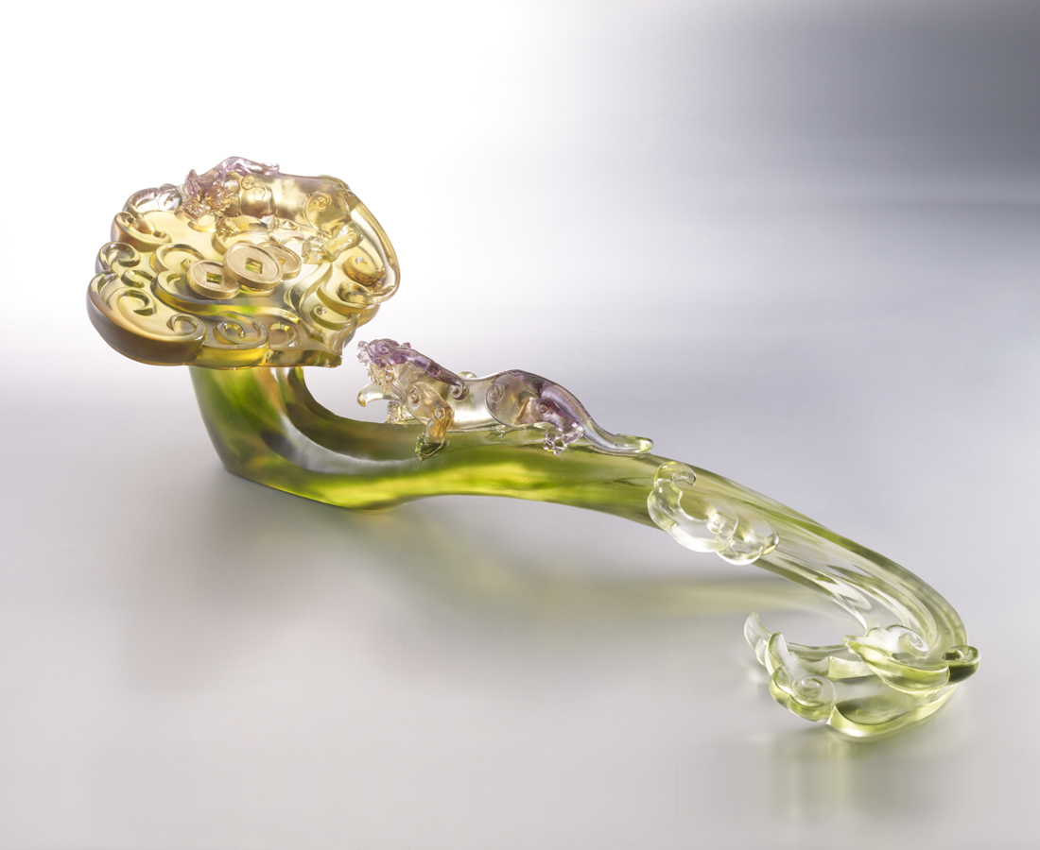
起伏有序的節拍
志同道合
無數次的高潮迭起
前呼後應
終將一路如意滿載
Pixiu Ruyi
Tittot makes the Ruyi with Pixiu which symbolizes the career and fortune in Chinese culture, wishing everybody have great success in the career.

編號 | 1503723 | No | 1503723
名稱 | 宜祿如意 | Name | Pixiu Ruyi
顏色 | 藍綠紫琥透＋金箔 | Color | blue, green, purple, amber, clear + gild
尺寸 | 58.3 * 16.9 * 17 | Size | 58.3 * 16.9 * 17
重量 | 5.6 | Weight | 5.6
限量 | O | Limited Edition | O
售價 | NT$ 98000 | Price | NT$ 98000
 | RMB$ 21800 |  | RMB$ 21800

