事事好平安 | 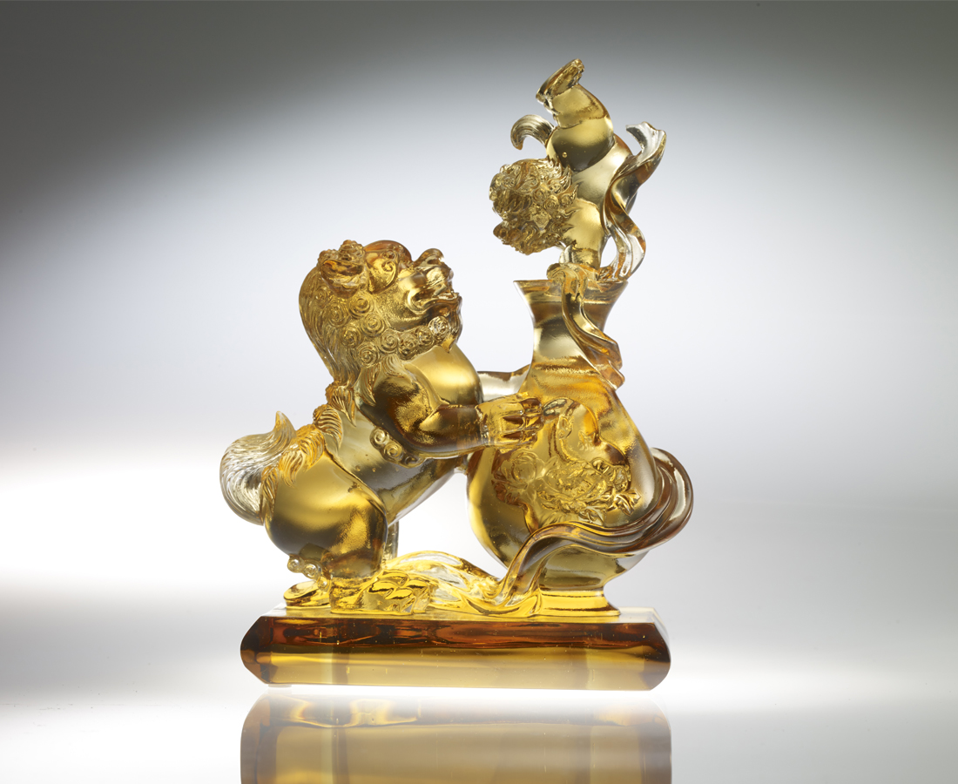
靈巧一轉
運勢大不同
無論大小事
平安大吉利
Vases and two lions
In Chinese culture, lion symbolizes good things, while vase has a homophonic sound, meaning peace. Two lions are playing next to a vase, thereby blessing everyone as safe.

編號 | 1503639 | No | 1503639
名稱 | 事事好平安 | Name | Vases and two lions
顏色 | 茶金透 | Color | brown ,golden ,clear
尺寸 | 7 * 12.2 * 17.5 | Size | 7 * 12.2 * 17.5
重量 | 1.35 | Weight | 1.35
限量 | X | Limited Edition | X
售價 | NT$ 12760 | Price | NT$ 12760
 | RMB$ 2850 |  | RMB$ 2850

