在握 | 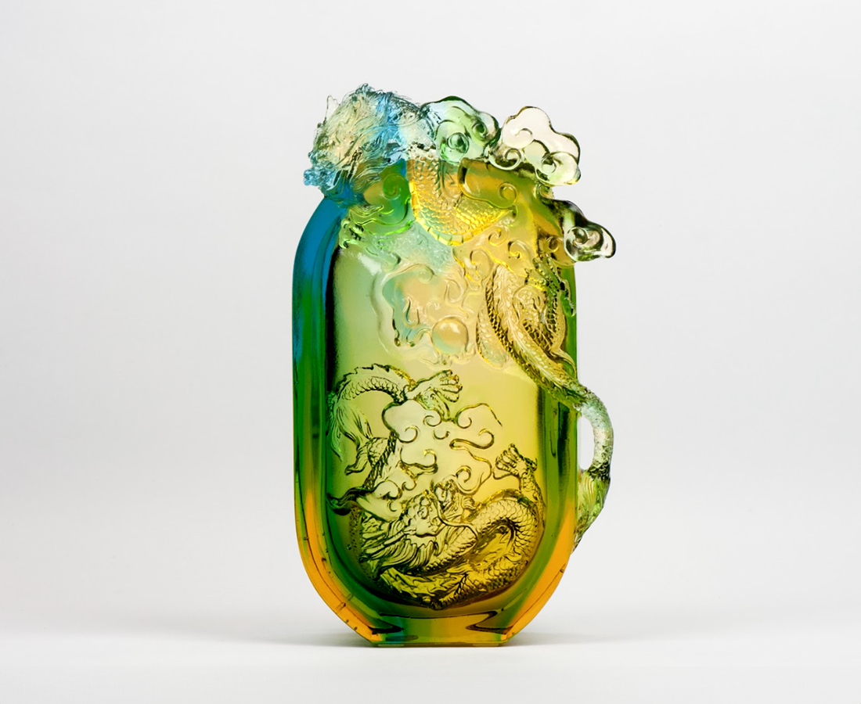
洞燭機先 成竹在胸
指點江山 驪珠在握
新氣象 舍我其誰
Two dragons Paperweight
Tittot uses translucent property of glass, manner of mixing embossed and intaglio modes to echo the front and rear double-sided dragon, giving the paperweight distinctive form of fun.

編號 | 1503636 | No | 1503636
名稱 | 在握 | Name | Two dragons Paperweight
顏色 | 青綠金透 | Color | cyan ,golden ,clear
尺寸 | 9.8 * 5 * 17 | Size | 9.8 * 5 * 17
重量 | 0.95 | Weight | 0.95
限量 | X | Limited Edition | X
售價 | NT$ 8700 | Price | NT$ 8700
 | RMB$ 1940 |  | RMB$ 1940

