福在握 | 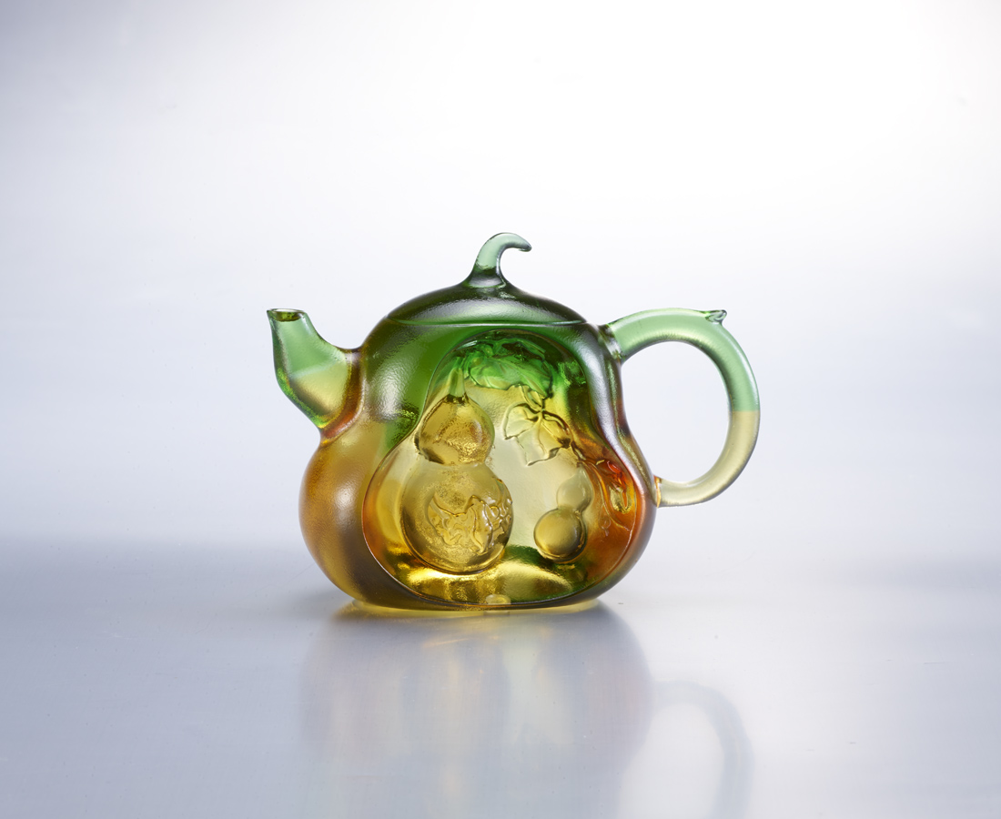
可以清心也
事事都無礙
天寬地闊
福氣在握
Bottle Gourd Teapot
In Chinese culture, tea drinking is an art of living with long history. In the Ming Dynasty and Qing Dynasty, craftsmen made teapots into various meaningful and interesting forms so that tea drinking is not only enjoying the taste of tea, but also enjoying the art of visual and tactile. Gourd symbolizes “continued good luck” in Chinese culture.

編號 | 1503582 | No | 1503582
名稱 | 福在握 | Name | Bottle Gourd Teapot
顏色 | 琥綠透 + 扇形底座 | Color | amber , green , clear ＋ stand
尺寸 | 12.8 * 6.4 * 9.7 | Size | 12.8 * 6.4 * 9.7
重量 | 0.76 | Weight | 0.76
限量 | X | Limited Edition | X
售價 | NT$ 6080 | Price | NT$ 6080
 | RMB$ 1350 |  | RMB$ 1350

