躍龍門 | 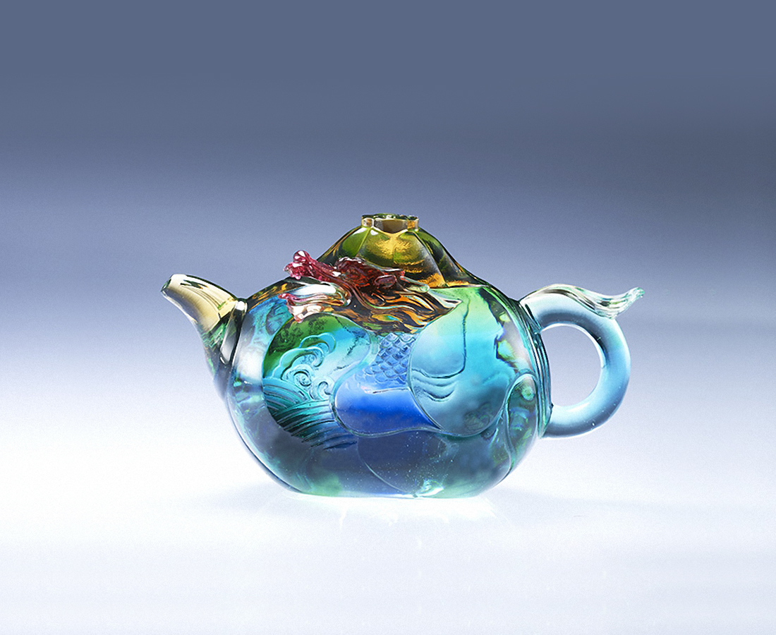
也可以清心
轉身路更遠
出人頭地
一躍龍門
Chinese Dragon Small Teapot
In Chinese culture, tea drinking is an art of living with long history. In the Ming Dynasty and Qing Dynasty, craftsmen made teapots into various meaningful and interesting forms so that tea drinking is not only enjoying the taste of tea, but also enjoying the art of visual and tactile.This design is from a well-known Chinese proverb "a carp leaps through Longmen". In ancient times, Chinese people observed that carps could be swim upstream in the Yellow River. Therefore, it turns into a legend that a carp will transform into a dragon when it swims against the stream and leaps across the waterfall. This proverb is used as a symbol of one's success.

編號 | 1503577 | No | 1503577
名稱 | 躍龍門 | Name | Chinese Dragon Small Teapot
顏色 | 琥青綠藍透 + 圓形底座 | Color | amber , cyan , green , blue , clear ＋ st
尺寸 | 15.5 * 7.8 * 9 | Size | 15.5 * 7.8 * 9
重量 | 1.0 | Weight | 1.0
限量 | X | Limited Edition | X
售價 | NT$ 7380 | Price | NT$ 7380
 | RMB$ 1650 |  | RMB$ 1650

