氣蓋山河 | 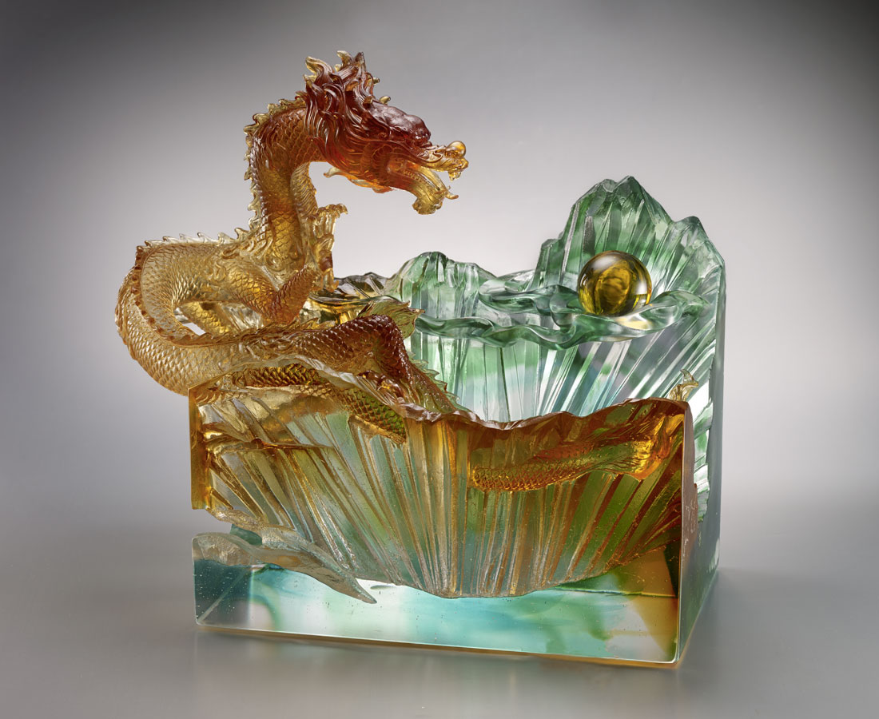
蟠起凌天地的壯志
吞吐耀河山的氣魄
磅礴大器 無所不能
建功立業 瑞氣呈祥
Ambitious Signs
The dragon flying over the mountains represents the idea of climbing over mountains and seizing the precious dragon ball hidden among them, which symbolizes that we can overcome whatever difficulties lie ahead, seize advantages and usher in a new world.

編號 | 1503410 | No | 1503410
名稱 | 氣蓋山河 | Name | Ambitious Signs
顏色 | 藍綠琥透 + 琥球 | Color | blue, green, amber, clear + amber ball
尺寸 | 40 * 22 * 39 | Size | 40 * 22 * 39
重量 | 35.6 | Weight | 35.6
限量 | O | Limited Edition | O
售價 | NT$ 148000 | Price | NT$ 148000
 | RMB$ 32900 |  | RMB$ 32900

