探驪得珠 | 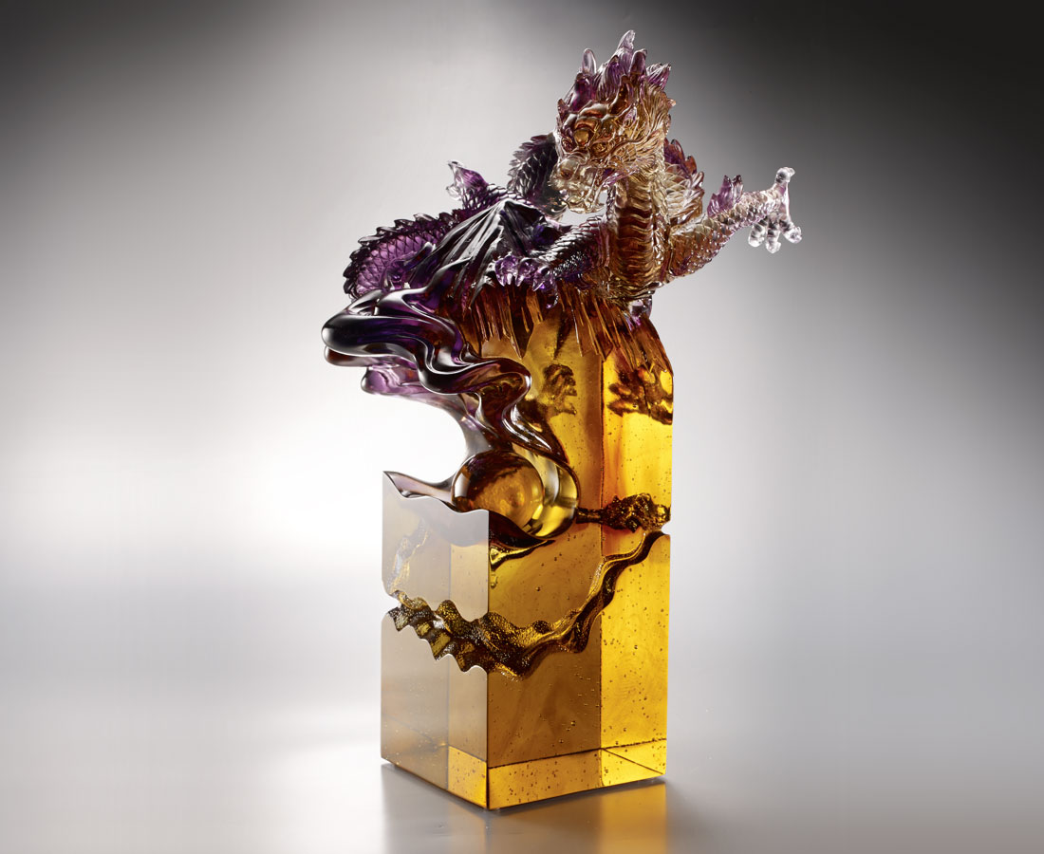
上窮雲霄 下探九重
察功業之關鍵
膽大心細 眼快手穩
握通達之要領
立穩根基 剛柔並濟
直入核心 探驪得珠
Seize the dragon ball
Legend has it that every dragon guards a precious gem, and only those brave enough may get it through unimaginable hardship. Using the image of a dragon guarding the precious gem in the mountain, this artwork of Tittot implies that one may overcome the crucial matters in one’s career and achieve great success with strong will and perseverance.

編號 | 1503409 | No | 1503409
名稱 | 探驪得珠 | Name | Seize the dragon ball
顏色 | 金紫茶透 + 琥球 | Color
尺寸 | 25.7 * 22.8 * 40.2 | Size | 25.7 * 22.8 * 40.2
重量 | 8.6 | Weight | 8.6
限量 | O | Limited Edition | O
售價 | NT$ 69800 | Price | NT$ 69800
 | RMB$ 15500 |  | RMB$ 15500

