旗開得勝 | 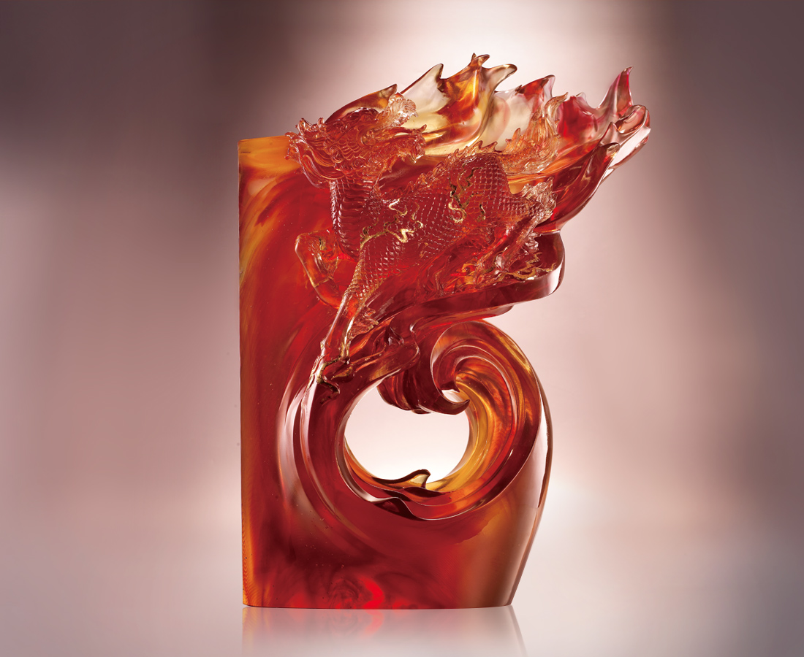
旗正飄飄 麒聲躂躂
回首金戈鐵馬 熱血翻騰
氣蓋雲天如龍 壯志四海
再耀逐鹿中原 旗開得勝
Invincible Kylin
The flags wave; a unicorn makes a distinctive sound Looking back at the shining spears and the armored horses The blood of the brave surges With a strong momentum like the dragon in the sky Great aspirations conquer the world Fighting for the territory in the central plain To win victory and shine like a star

編號 | 1503253 | No | 1503253
名稱 | 旗開得勝 | Name | Invincible Kylin
顏色 | 琥紅透 | Color | null
尺寸 | 21 * 37 * 50 | Size | 21 * 37 * 50
重量 | 31.0 | Weight | 31.0
限量 | O | Limited Edition | O
售價 | NT$ 153890 | Price | NT$ 153890
 | RMB$ 34200 |  | RMB$ 34200

