出神入化 | 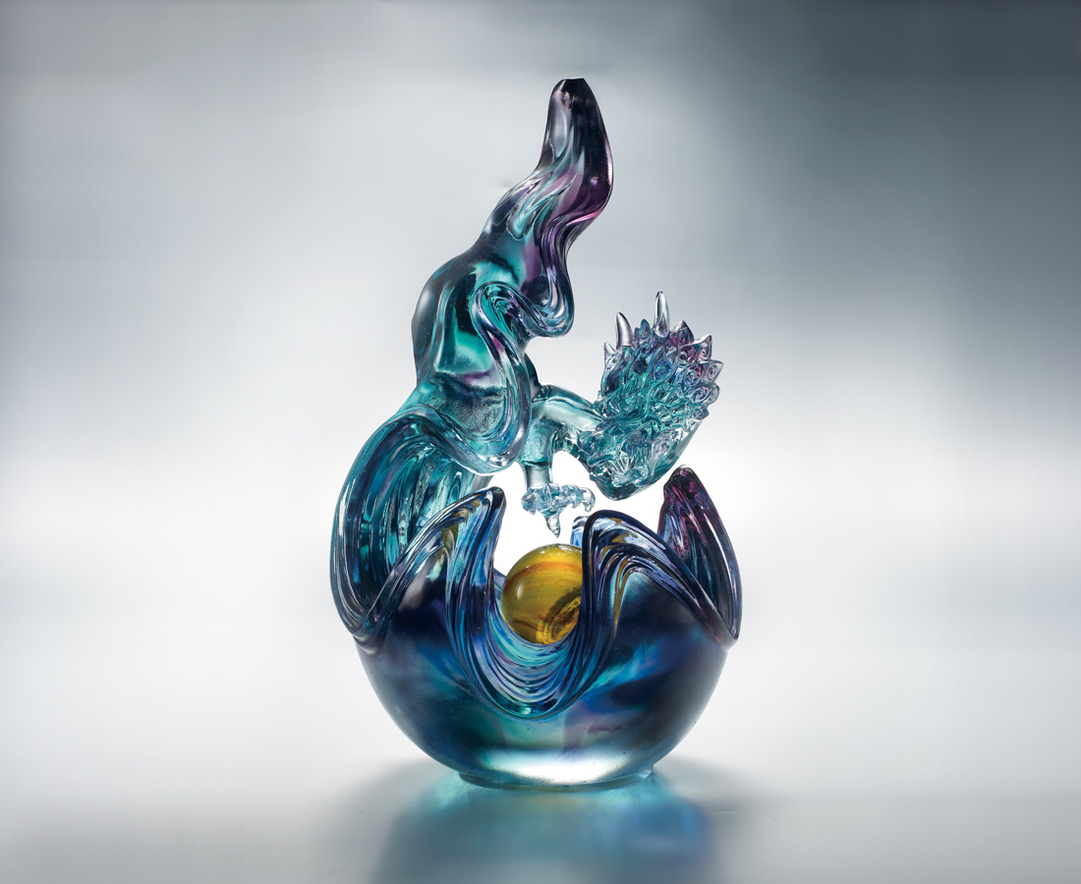
興 大江大海
嘯 高山深谷
捲風雲 動天地
一身技藝 超神入化
再起舞朝陽爭光輝
Omnipotent Chinese Dragon
Excitement in the river and the sea Roaring sounds from the deep mountains and valleys The shaking of the heavens And the earth responds to the moving wind and clouds With superb expertise Reawaken the shining glory of the dragon's ball

編號 | 1503252 | No | 1503252
名稱 | 出神入化 | Name | Omnipotent Chinese Dragon
顏色 | 玻璃:藍青紫透+球:琥 | Color
尺寸 | 19.8 * 20.6 * 36 | Size | 19.8 * 20.6 * 36
重量 | 8.25 | Weight | 8.25
限量 | O | Limited Edition | O
售價 | NT$ 48800 | Price | NT$ 48800
 | RMB$ 10880 |  | RMB$ 10880

