玄武開天 | 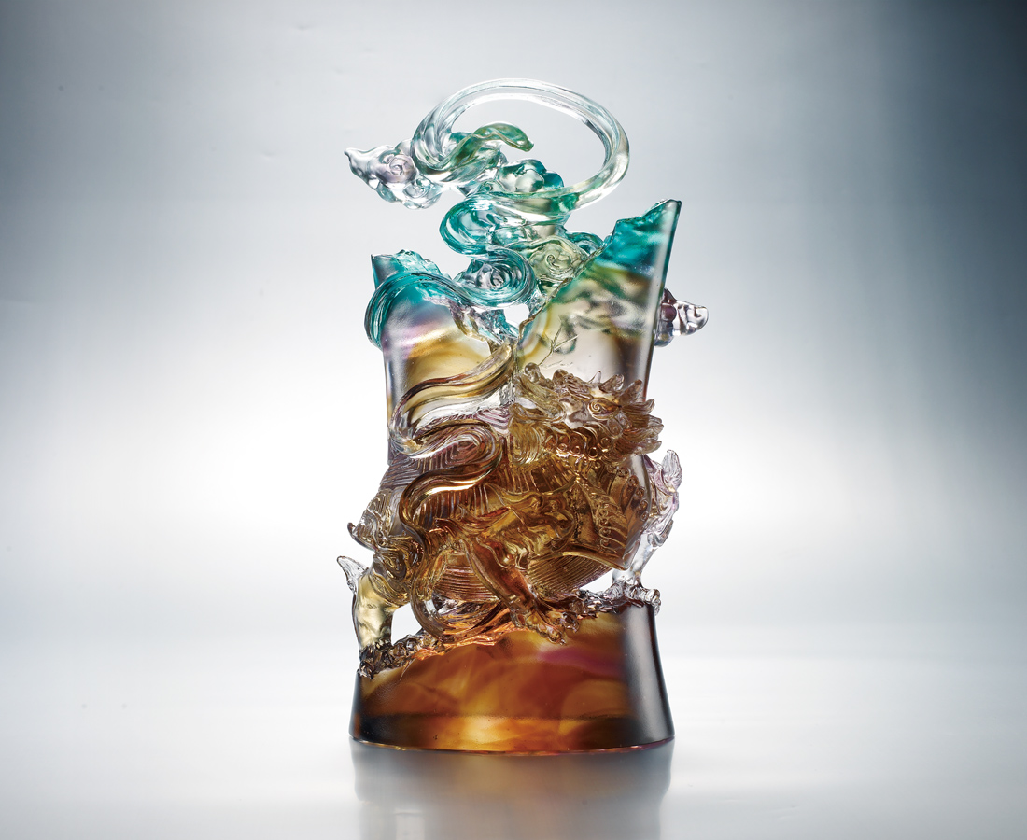
天高 浩蕩
氣壯 石破
披盔戴甲傲英雄
風雲四起開疆土
一舉功成永流長
Herculean Tortoise
The sky is high and boundless The momentum is strong enough to split the stone The heroes are armed with helmets and armors To fight for territory with a strong determination To keep achievements lasting forever

編號 | 1503251 | No | 1503251
名稱 | 玄武開天 | Name | Herculean Tortoise
顏色 | 茶青紫透 | Color
尺寸 | 12.5 * 15 * 28 | Size | 12.5 * 15 * 28
重量 | 4.14 | Weight | 4.14
限量 | O | Limited Edition | O
售價 | NT$ 33800 | Price | NT$ 33800
 | RMB$ 8000 |  | RMB$ 8000

