百結如意 | 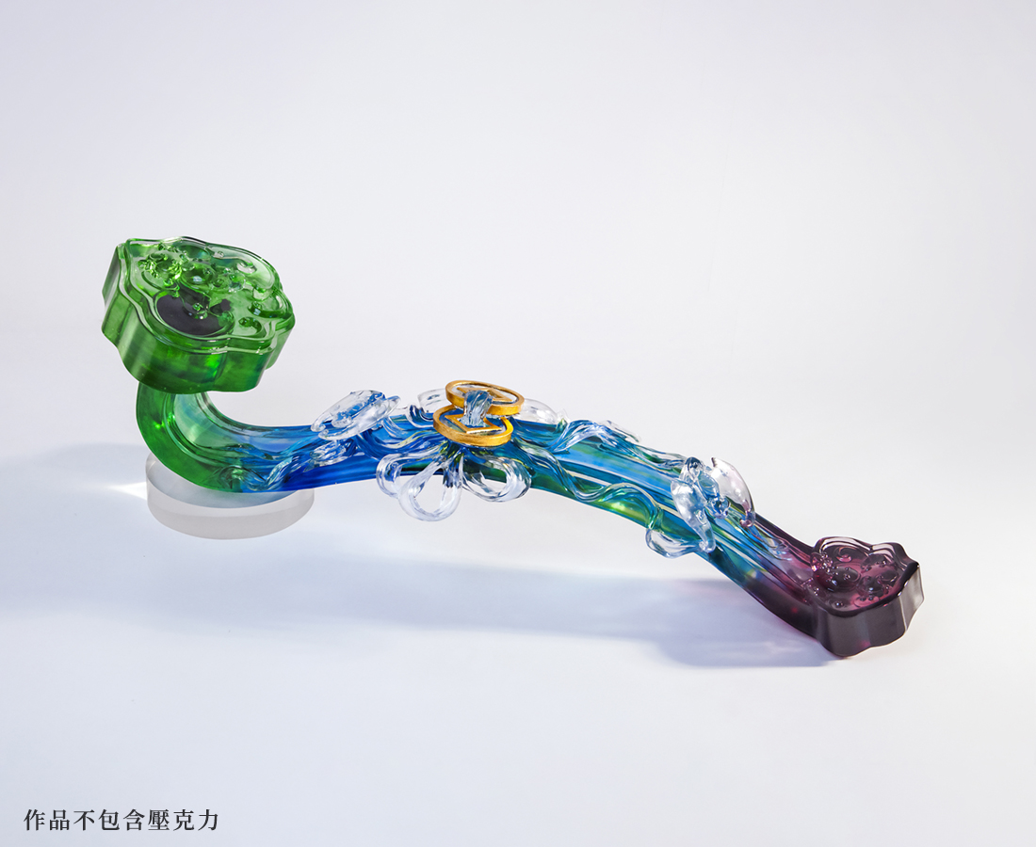
繫天圓地方的同心結
壯志有懷 昂昂然高朗
福到眼前 燦燦然交響
向高潮迭起如意暢行
Auspiciously Knotted Wishes
One true love’s knot, a symbol of harmony and common prosperity With a vision to a far end, and a will towards a grand goal Luck comes with confidence And the auspicious bat symbolizes the smooth lines of Ruyi

編號 | 1503243 | No | 1503243
名稱 | 百結如意 | Name | Auspiciously Knotted Wishes
顏色 | 藍綠紫透 | Color | null
尺寸 | 78.2 * 19.3 * 18.6 | Size | 78.2 * 19.3 * 18.6
重量 | 0.0 | Weight | 0.0
限量 | O | Limited Edition | O
售價 | NT$ 217800 | Price | NT$ 217800
 | RMB$ 48400 |  | RMB$ 48400

