登高望 | 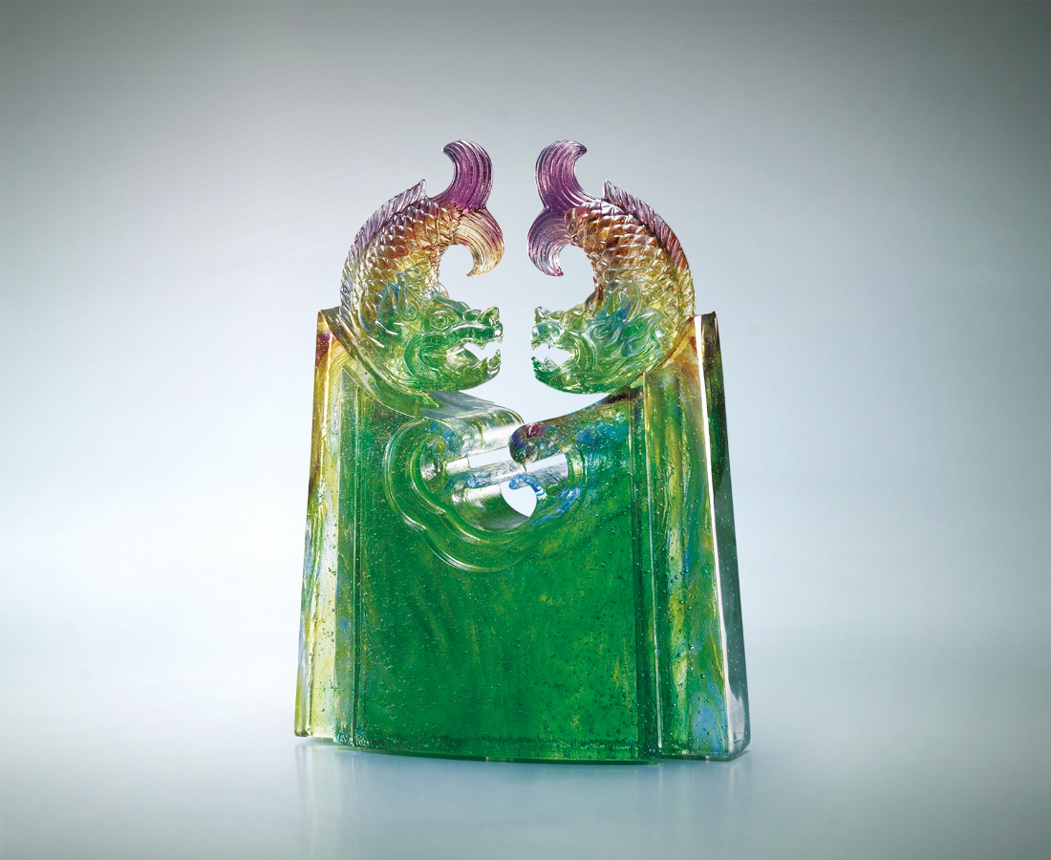
眼對眼 居高臨下
看海闊天空
再勇往 縱身投入
如意接福祿
Vantage Point
Facing each other from a vantage point Overlooking the boundless ocean and sky Thrust forward with dedication and commitment Good fortune and prosperity will soon follow

編號 | 1502992 | No | 1502992
名稱 | 登高望 | Name | Vantage Point
顏色 | 藍綠琥紫透 | Color
尺寸 | 5 * 11.8 * 14.5 | Size | 5 * 11.8 * 14.5
重量 | 0.9 | Weight | 0.9
限量 | X | Limited Edition | X
售價 | NT$ 7680 | Price | NT$ 7680
 | RMB$ 1700 |  | RMB$ 1700

