幸福無疆 | 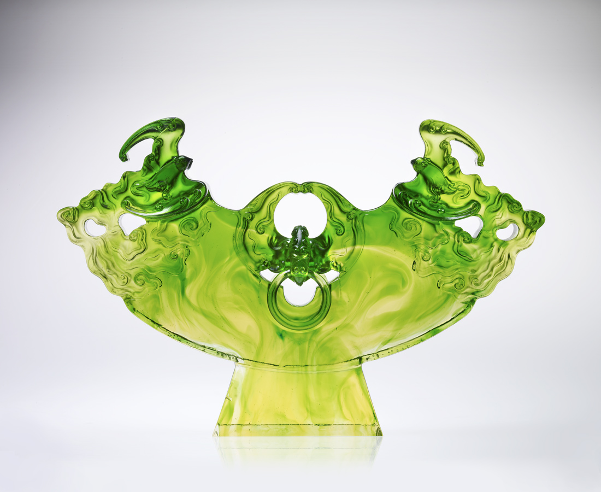
展開 成功的自信
弛放 甜美的夢想
開誠佈公 竭盡所能
緊扣 創始的精神
守穩 嚴謹的風格
幸福風景 一望無際
Bliss Beyond Horizon
Command, it is self-confidence to succeed Relax, that a dream shall turn sweet To all exhale truly yours; emotion, devotion, you give them all Though bliss was coined in Golden Pond, For you, it rides to horizon and beyond

編號 | 1502569 | No | 1502569
名稱 | 幸福無疆 | Name | Bliss Beyond Horizon
顏色 | 青綠藍透 | Color
尺寸 | 11 * 48.2 * 31.6 | Size | 11 * 48.2 * 31.6
重量 | 11.1 | Weight | 11.1
限量 | O | Limited Edition | O
售價 | NT$ 161000 | Price | NT$ 161000
 | RMB$ 36688 |  | RMB$ 36688

