寰宇祥獅 | 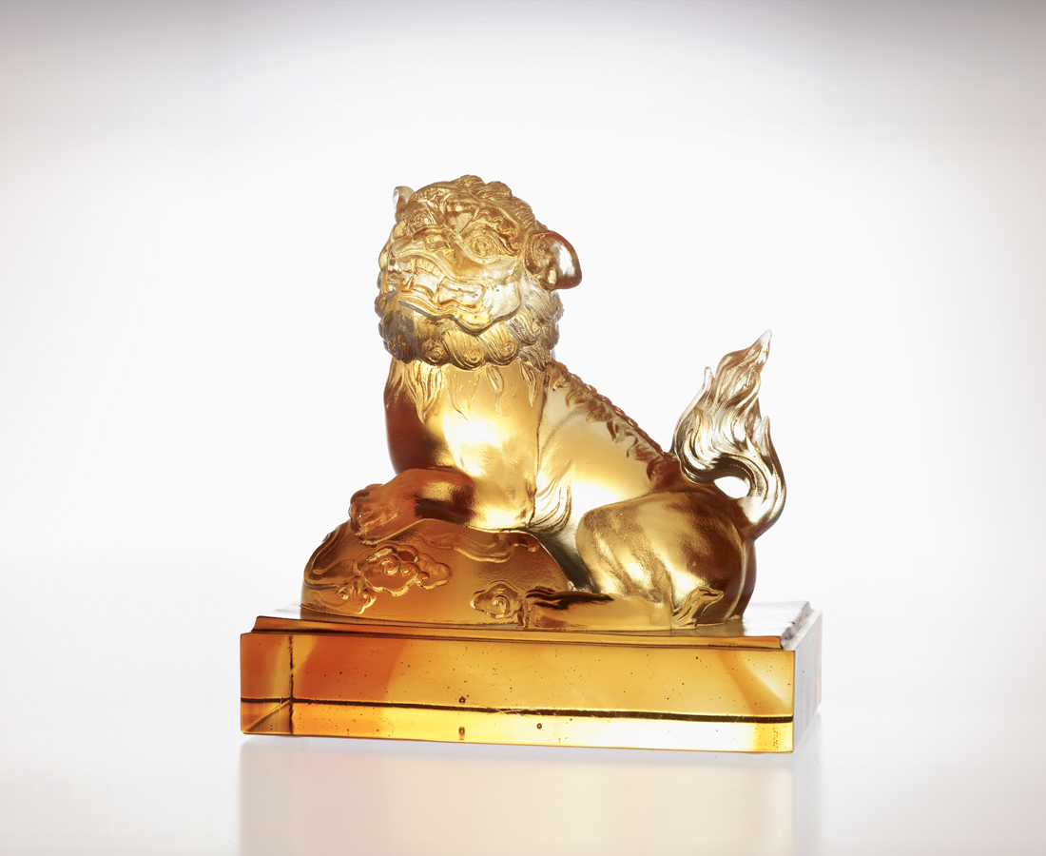
重如泰山的情義
赤誠丹心比日月
風雲叱吒的理想
熱情燃燒比山河
信心高漲 見識過人
祥獅君臨 八方如意
The Blessed Lion
Strong power of love and faith Undoubted eternal friendship Pursuing dreams like lions pursuing preys Together with faithful friends Confidence keeps on growing The blessed lion will bring in good fortune and luck

編號 | 1502555 | No | 1502555
名稱 | 寰宇祥獅 | Name | The Blessed Lion
顏色 | 琥透 | Color | amber, clear
尺寸 | 10.8 * 6.6 * 11 | Size | 10.8 * 6.6 * 11
重量 | 0.82 | Weight | 0.82
限量 | X | Limited Edition | X
售價 | NT$ 5680 | Price | NT$ 5680
 | RMB$ 1410 |  | RMB$ 1410

