好緣好圓 | 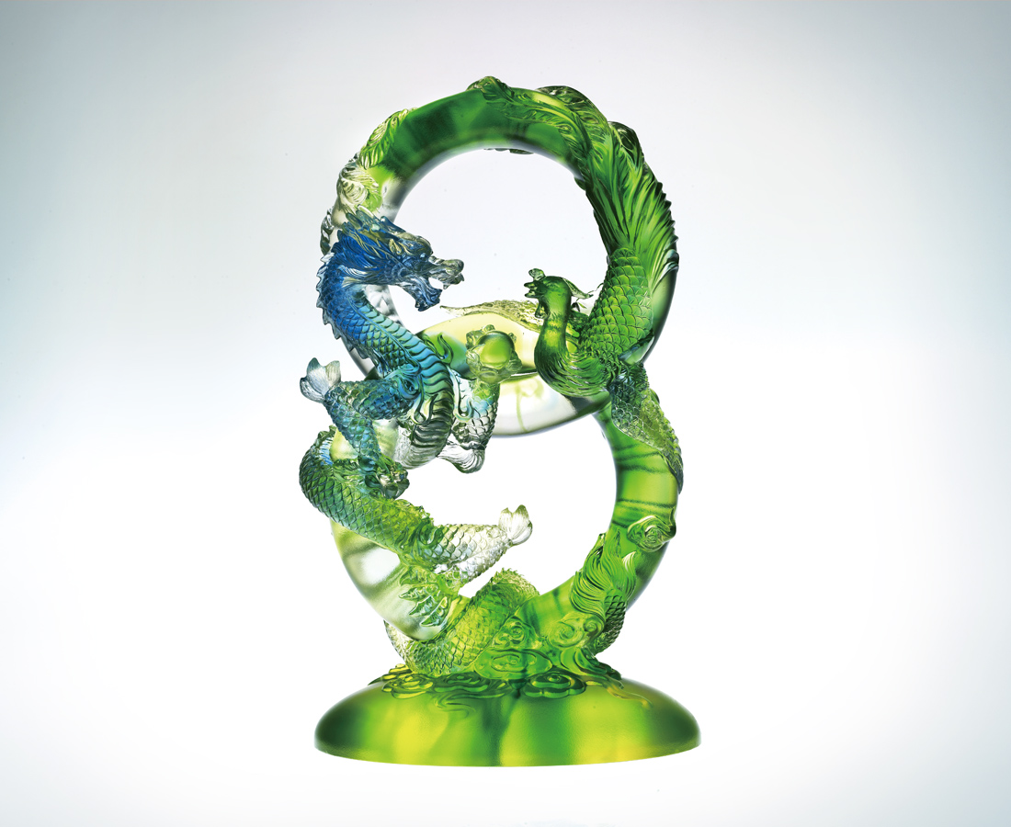
歲月周而復始流轉
你我有始有終相隨
好緣好圓環環相扣
Divine Blessings
In endless circles as time flows We love each other from head to toe What goes round comes around Here comes fate that keeps us bound

編號 | 1502547 | No | 1502547
名稱 | 好緣好圓 | Name | Divine Blessings
顏色 | 金綠青透 | Color
尺寸 | 10.8 * 16.2 * 27 | Size | 10.8 * 16.2 * 27
重量 | 3.07 | Weight | 3.07
限量 | O | Limited Edition | O
售價 | NT$ 39560 | Price | NT$ 39560
 | RMB$ 8166 |  | RMB$ 8166

