天地如龍 | 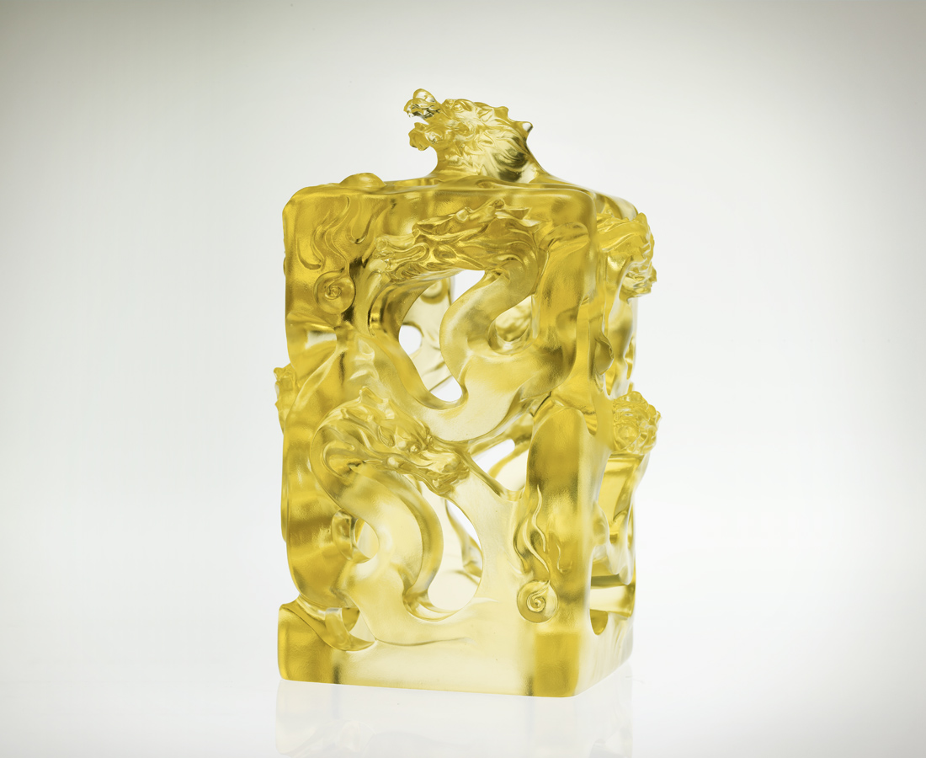
其動昂然沉潛 抑揚頓挫
其氣進退有序 生生不息
而現事業生活 九龍騰天
Kingdom Of The Dragon
When the determined moves, there is no hesitation But precise with deliberation It persists and leaves no disorder, thus lives its spirit Now and Forever Give me a daily drill of such, shall a kingdom of success Come firmly in my clutch

編號 | 1502533 | No | 1502533
名稱 | 天地如龍 | Name | Kingdom Of The Dragon
顏色 | 金 | Color | null
尺寸 | 14.5 * 14.5 * 22 | Size | 14.5 * 14.5 * 22
重量 | 4.15 | Weight | 4.15
限量 | O | Limited Edition | O
售價 | NT$ 39260 | Price | NT$ 39260
 | RMB$ 8888 |  | RMB$ 8888

