富貴雙收 | 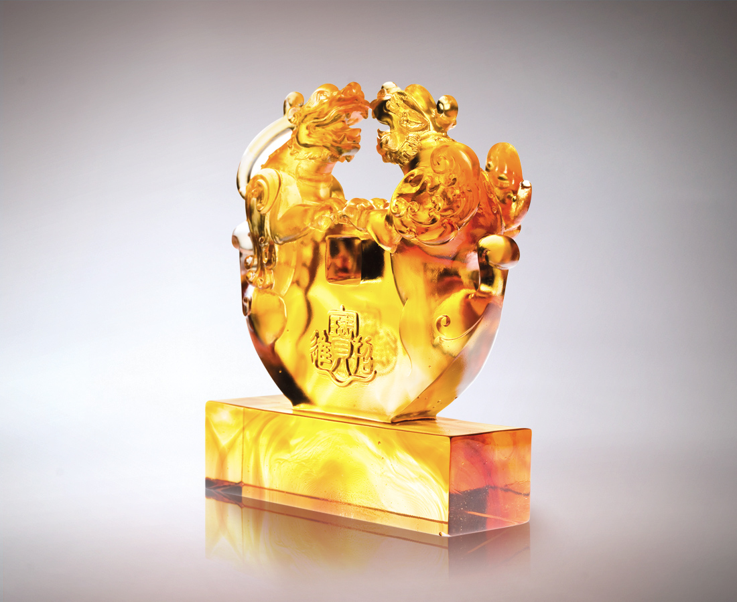
口口張吞智慧經驗
聲聲鼓舞勇猛威勢
心細膽大 自信飽滿
真心相對 誠意聯手
而天地圓融風生水起
人和興旺 富貴雙收
Prestige and Prosperity
Opening wide to wisdom and experience Roaring forth to challenge and impress So careful, so confident So trusting, so united The heavens and the earth are in harmony Working together Gain both prestige and prosperity

編號 | 1502446 | No | 1502446
名稱 | 富貴雙收 | Name | Prestige and Prosperity
顏色 | 琥透 | Color | amber, clear
尺寸 | 5 * 18 * 19.8 | Size | 5 * 18 * 19.8
重量 | 2.6 | Weight | 2.6
限量 | O | Limited Edition | O
售價 | NT$ 20100 | Price | NT$ 20100
 | RMB$ 5050 |  | RMB$ 5050

