麒麟開泰 | 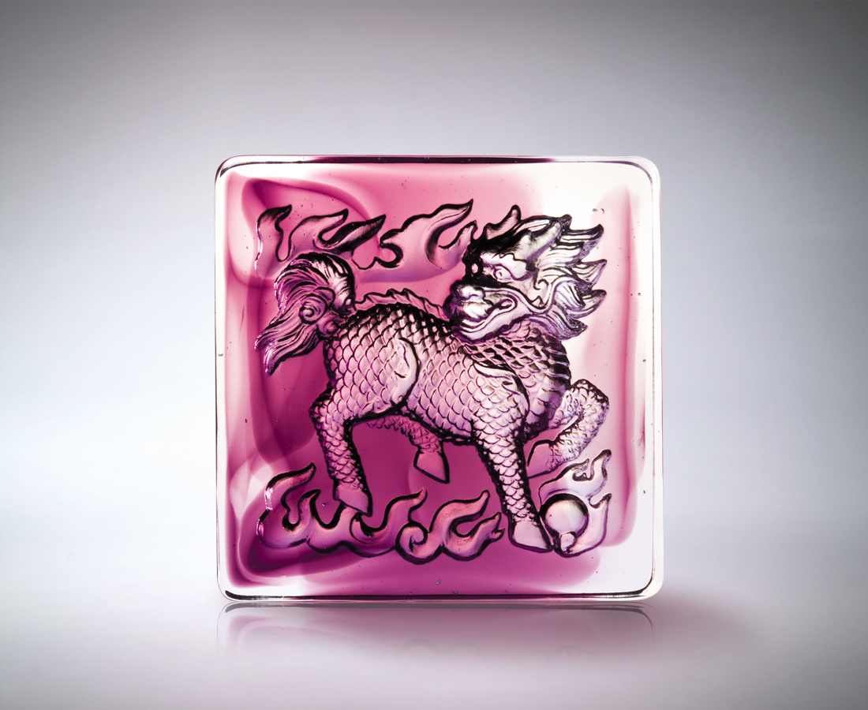
在中土
好風好水的榮景
伺機而發
四面八方的佈局
按步就班 五穀豐登
麒麟躍 一生開泰
Unicorn Brings Good Tidings
On this good earth Where the landscape is enveloped with good geomantic omen Awaiting the opportune moment Executing well-laid plans Take things in stride and good fortune beckons With mythical unicorn bringing glory and success

編號 | 1502378 | No | 1502378
名稱 | 麒麟開泰 | Name | Unicorn Brings Good Tidings
顏色 | 紫透 | Color
尺寸 | 8 * 8 * 3 | Size | 8 * 8 * 3
重量 | 0.52 | Weight | 0.52
限量 | X | Limited Edition | X
售價 | NT$ 2980 | Price | NT$ 2980
 | RMB$ 766 |  | RMB$ 766

