氣魄如龍 | 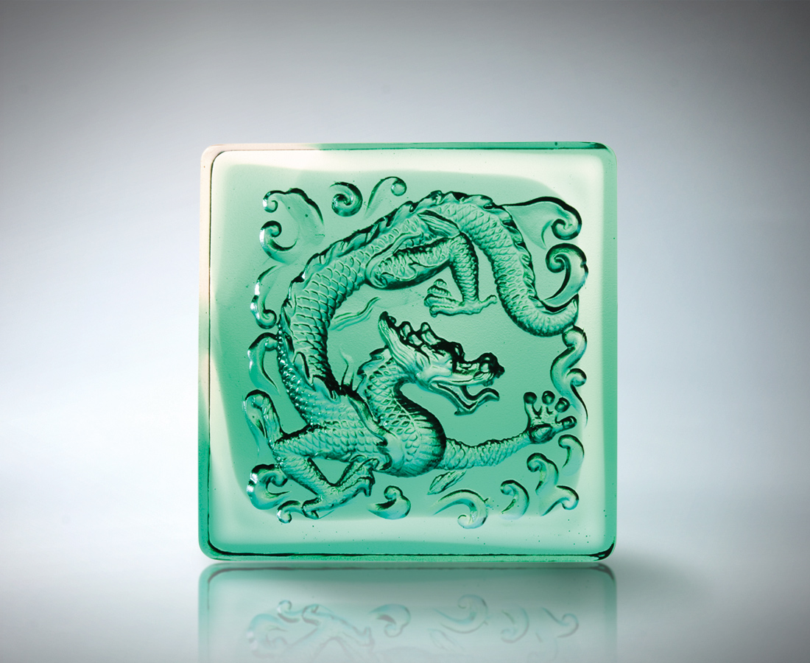
東蟠起
浩瀚長河的決心
一路翻騰
吞雲吐霧的滂礡
氣象萬千 雷霆撼天
如龍氣魄 無所不能
Power of the Dragon
The east stirs up A heart filled with determination, forceful like the rushing river Rolling and gushing Spouting magnificent clouds of mist Enveloping the air, striking an imposing presence Like the majestic and omnipresent dragon

編號 | 1502377 | No | 1502377
名稱 | 氣魄如龍 | Name | Power of the Dragon
顏色 | 粉綠透 | Color
尺寸 | 8 * 8 * 4 | Size | 8 * 8 * 4
重量 | 0.49 | Weight | 0.49
限量 | X | Limited Edition | X
售價 | NT$ 2980 | Price | NT$ 2980
 | RMB$ 766 |  | RMB$ 766

