鳳鳴昇平 | 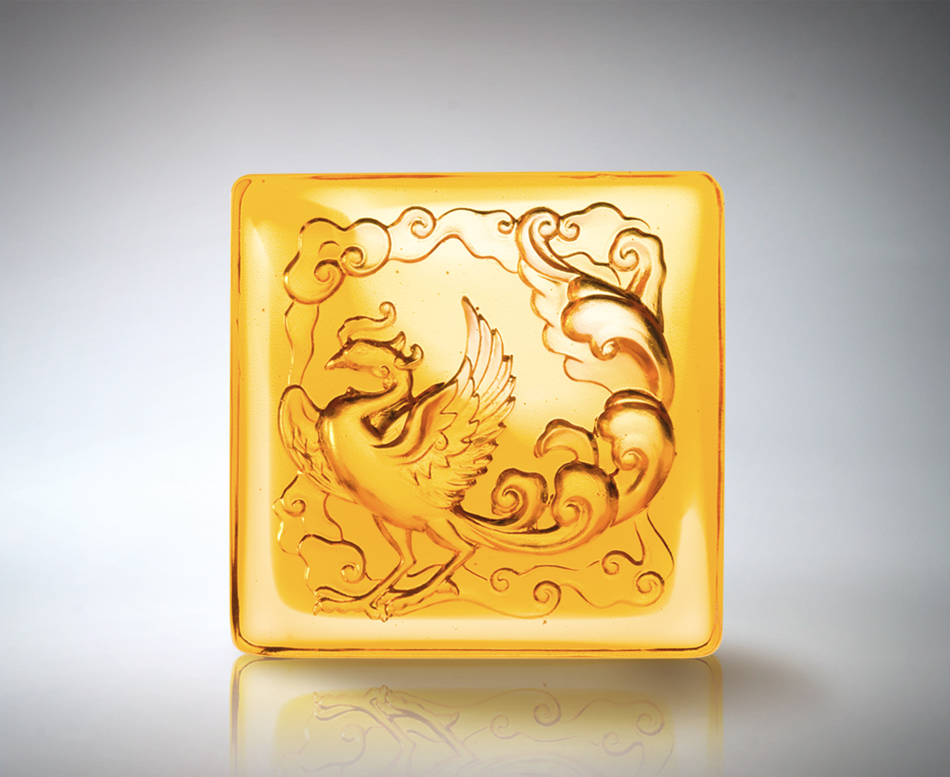
峙南於
廣闊平原的包容
昂首振翼
天下安寧的胸懷
萬世昇平 和合圓滿
有鳳來儀 雍容千秋
Blessings of the Phoenix
Nestled snugly in The benevolence of the vast grasslands The majestic arms open wide Embracing peace and serenity on earth Harmony and unity for ever and ever The auspicious phoenix brings many years of grandeur

編號 | 1502376 | No | 1502376
名稱 | 鳳鳴昇平 | Name | Blessings of the Phoenix
顏色 | 琥透 | Color
尺寸 | 8 * 8 * 3 | Size | 8 * 8 * 3
重量 | 0.53 | Weight | 0.53
限量 | X | Limited Edition | X
售價 | NT$ 2980 | Price | NT$ 2980
 | RMB$ 766 |  | RMB$ 766

