玄武長青 | 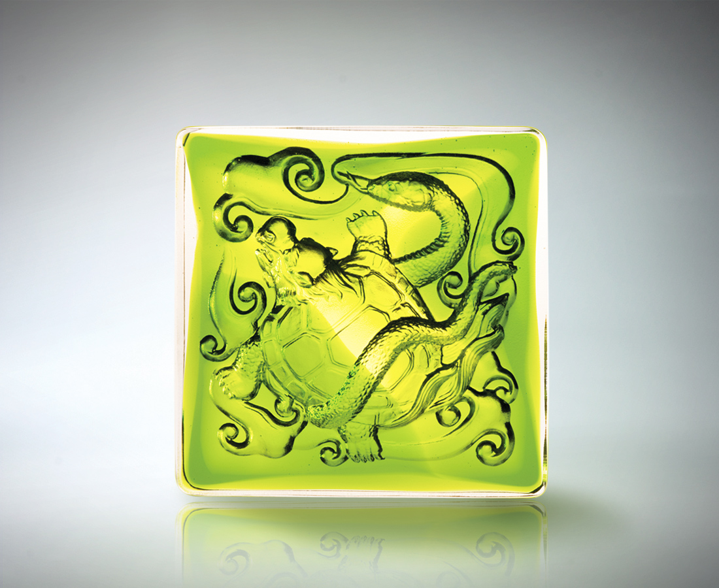
鎮北守
巍峨高山的雄偉
登高望遠
吸納浩瀚的豁達
五湖四海 自在至剛
源遠流長 富貴長青
Everlasting Black Tortoise
The city fortress Emanating power and awe like the majestic mountains Standing tall, seeing far and wide Captivated by the grandeur of the valleys Traveling freely to the ends of the earth, building strength upon strength Leaving a timeless legacy of good fortune

編號 | 1502374 | No | 1502374
名稱 | 玄武長青 | Name | Everlasting Black Tortoise
顏色 | 綠透 | Color
尺寸 | 8 * 8 * 3 | Size | 8 * 8 * 3
重量 | 0.52 | Weight | 0.52
限量 | X | Limited Edition | X
售價 | NT$ 2980 | Price | NT$ 2980
 | RMB$ 766 |  | RMB$ 766

