昂揚 | 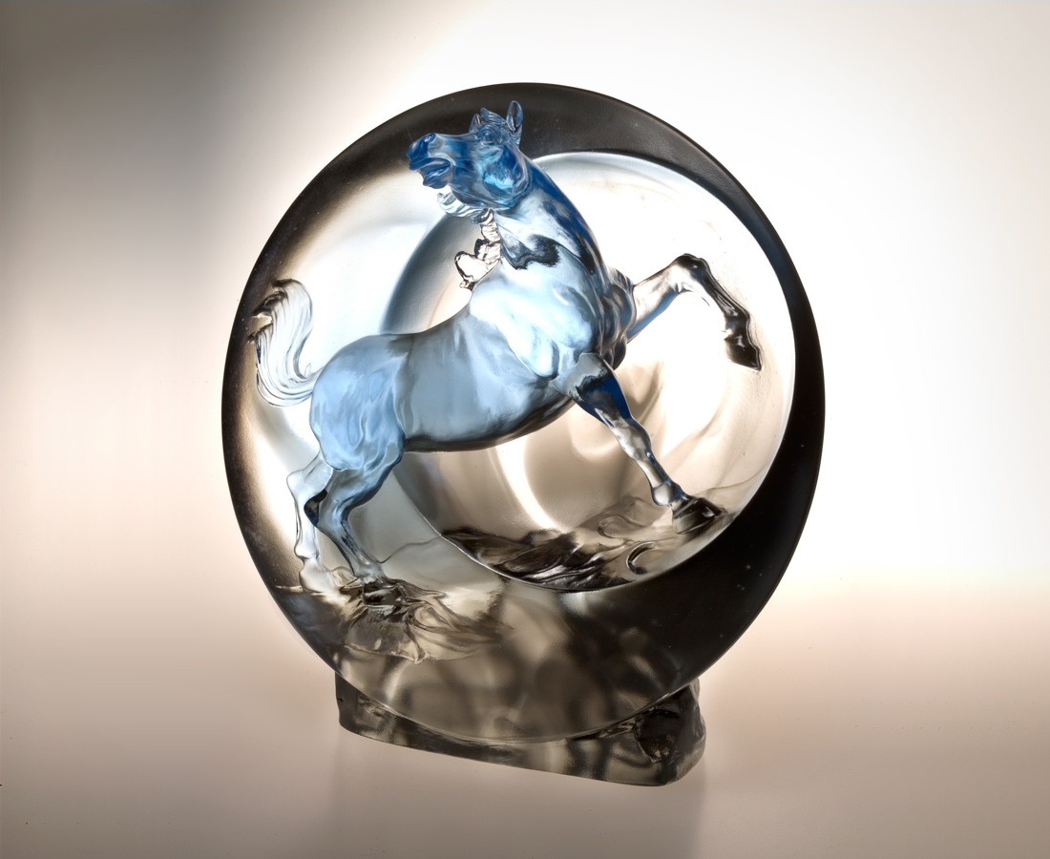
走過荒漠 穿梭日月
橫越山川 暢吟風雲
踏出一身的雄心壯志
跑出一心的熱情自信
站巔峰 意氣揚揚
High Spiritedness
Through time and tide Braving the elements of nature Building strength and high-spirited commitment Passion and confidence Standing tall, exuding ambitious conviction

編號 | 1502256 | No | 1502256
名稱 | 昂揚 | Name | High Spiritedness
顏色 | 藍灰透 | Color
尺寸 | 9 * 17.7 * 17.5 | Size | 9 * 17.7 * 17.5
重量 | 3.28 | Weight | 3.28
限量 | O | Limited Edition | O
售價 | NT$ 23800 | Price | NT$ 23800
 | RMB$ 5288 |  | RMB$ 5288

