拍響榮耀 | 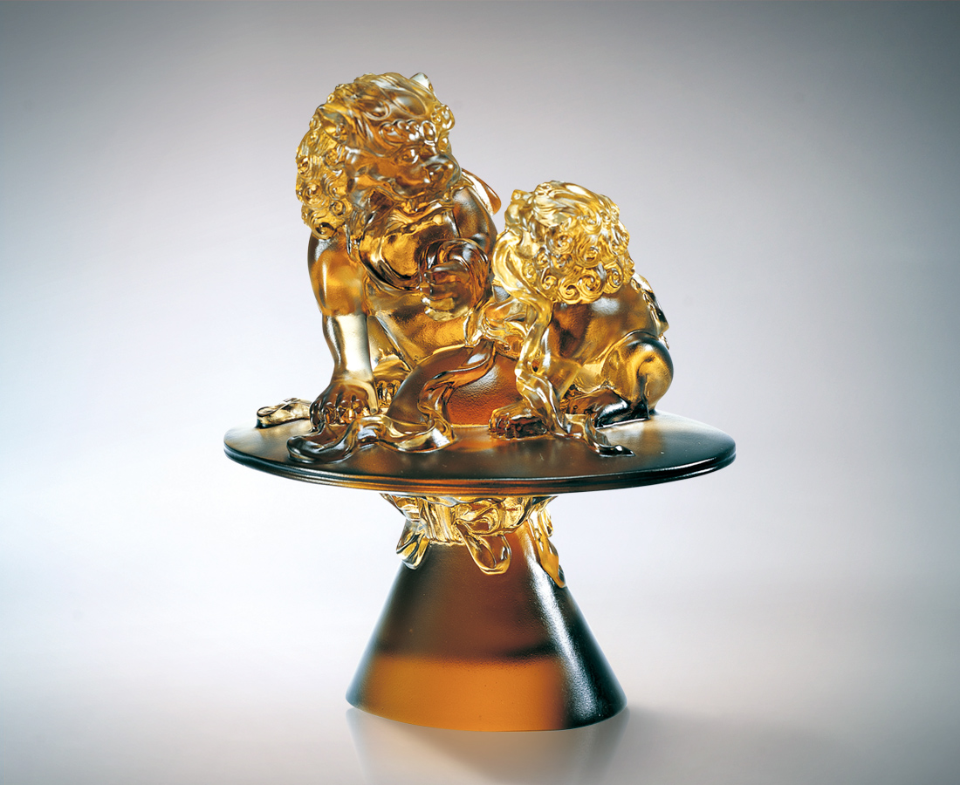
牽連如影隨形的關懷
傳動繼往開來的智慧
開鈸勇往直前的自信
建構開疆闢土的策略
尊貴的願景 不懼的血液
拍出承先啟後的宣誓
光榮的傳承 高昂的決心
敲出響徹雲霄的偉業
Applauding Honor
Involving concern that follows us like the shadow Transmitting intellect that has been passed down through the ages Igniting the confidence to charge ahead courageously Establishing trail-blazing strategies Venerable ambitions and blood ties Instigating the oath of responsibility and enlightenment Transmitting honor and determination Establishing a career of resounding success

編號 | 1502095 | No | 1502095
名稱 | 拍響榮耀 | Name | Applauding Honor
顏色 | 茶金 | Color
尺寸 | 11.2 * 14.5 * 17.7 | Size | 11.2 * 14.5 * 17.7
重量 | 1.96 | Weight | 1.96
限量 | O | Limited Edition | O
售價 | NT$ 12860 | Price | NT$ 12860
 | RMB$ 3222 |  | RMB$ 3222

