愉躍沖天 | 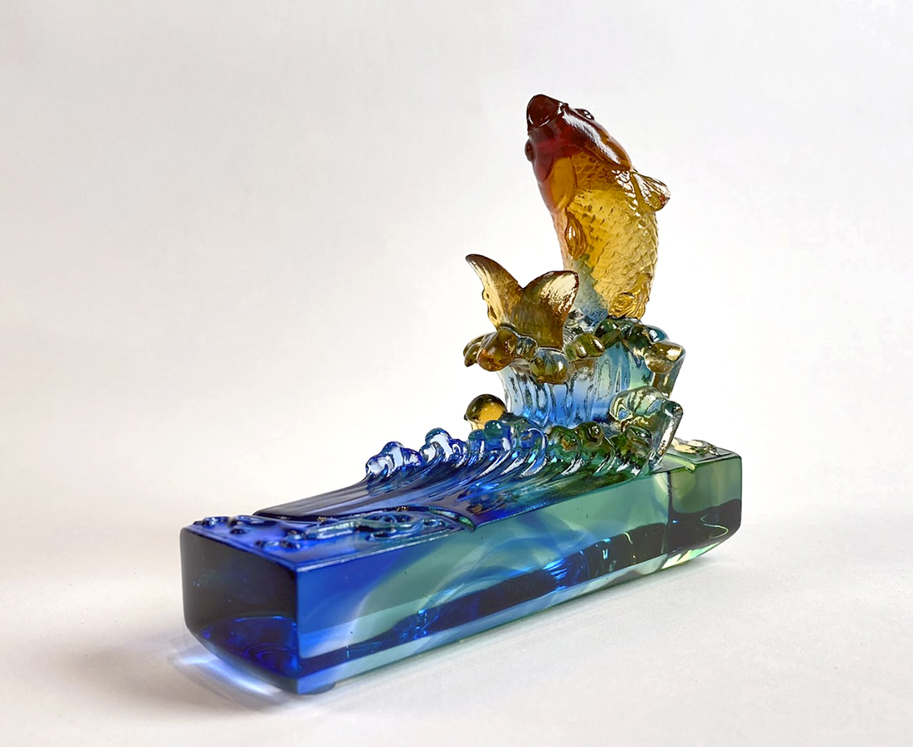
井然有序 積極回應
於慢板前奏 悄然就位
隨快板序曲 順勢加速
乘澎湃樂章 奮揚而上
高山流水一瀉千里
熱情激昂一飛沖天
鮮活愉躍 蒸蒸日上
Leaping Joyfully into the Skies
Responding actively in good order Get in position quietly in the andante preclude Speed up along with the allegro overture Ascending with full force along with the roaring notes Water takes a nosedive down the mountain Passion soars into the sky Rise and ascend with thriving vigor and leaping joy

編號 | 1502092 | No | 1502092
名稱 | 愉躍沖天 | Name | Leaping Joyfully into the Skies
顏色 | 金藍綠紅透 | Color | gold, blue, green, red, clear
尺寸 | 5.2 * 12.5 * 10.1 | Size | 5.2 * 12.5 * 10.1
重量 | 0.54 | Weight | 0.54
限量 | X | Limited Edition | X
售價 | NT$ 5880 | Price | NT$ 5880
 | RMB$ 1450 |  | RMB$ 1450

