鍾愛 | 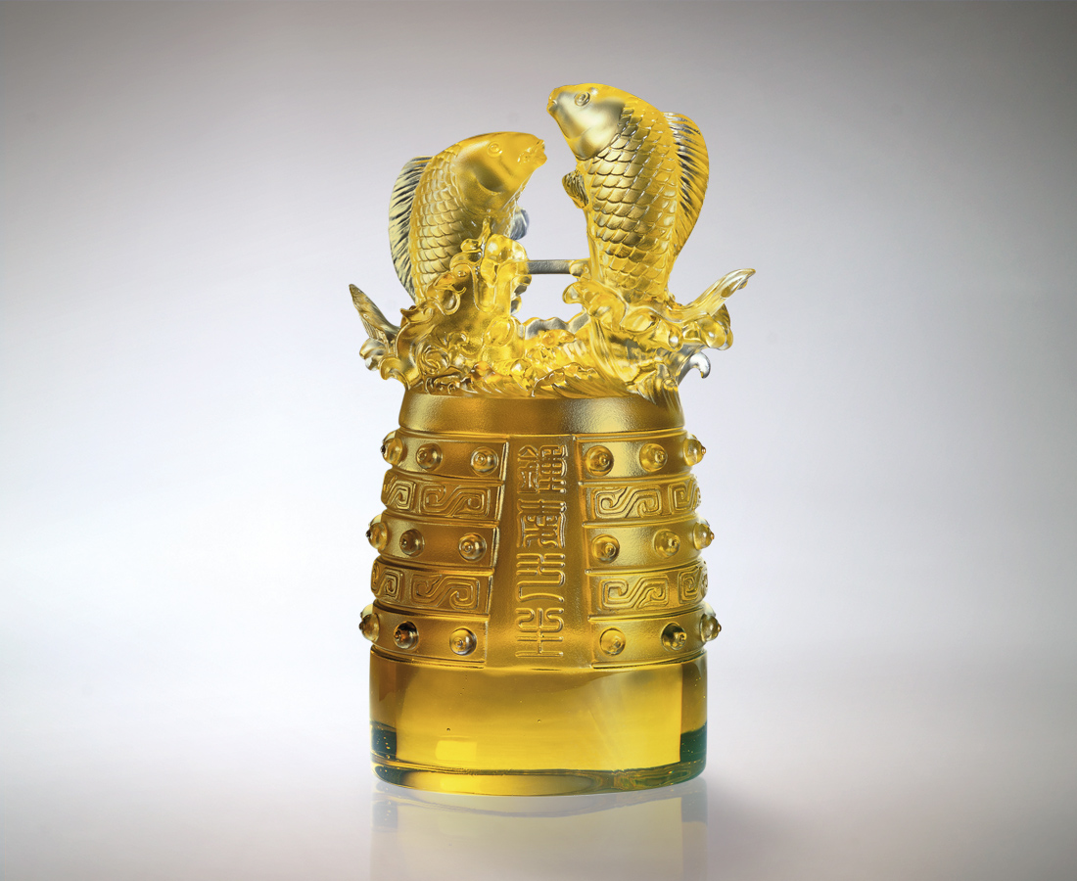
鐘聲響起
儀式隆重 神聖莊嚴
共鳴天長地久誓言
鐘聲響起
濃情歷歷 穿越時空
共震如潮生鮮激情
鐘聲響起
天長地久 餘音繚繞
共遊一往情深世界
沉穩聲響 永遠迴盪
愉躍幸福 鍾愛一生
Cherish
The bells toll In a solemn and holy ceremony Sharing the oath of eternity The bells toll Exalting the unwavering affection Sharing an undying passion The bells toll Echoing till eternity Sharing the path of true love The steady tolling echoes forever Bringing joy and happiness to be cherished forever

編號 | 1502091 | No | 1502091
名稱 | 鍾愛 | Name | Cherish
顏色 | 茶金 | Color
尺寸 | 7 * 11.2 * 18.7 | Size | 7 * 11.2 * 18.7
重量 | 2.1 | Weight | 2.1
限量 | O | Limited Edition | O
售價 | NT$ 13860 | Price | NT$ 13860
 | RMB$ 3466 |  | RMB$ 3466

