榮登寶座 | 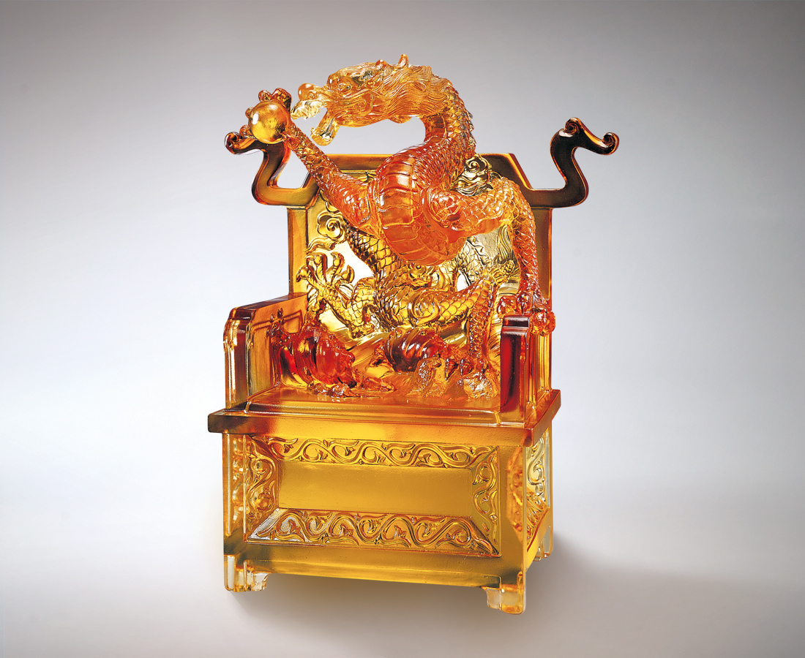
就在此刻
將聚足一世才智雄心
龍登舞台 迎向挑戰
多少考驗
只有勇氣 力挽狂瀾
多少障礙
只有真誠 扭轉乾坤
挺身而出 中流砥柱
真才實學 楷模天下
Taking the Seat of Leadership
At this moment in time Consolidate your knowledge and ambition Proceed with majestic courage to meet the challenge How many challenges Have been successfully overcome with courage How many obstacles Have been defeated with sincerity Step up and take the lead Be an exemplary model of competence

編號 | 1502088 | No | 1502088
名稱 | 榮登寶座 | Name | Taking the Seat of Leadership
顏色 | 金琥 | Color
尺寸 | 10.6 * 22.8 * 26.5 | Size | 10.6 * 22.8 * 26.5
重量 | 6.77 | Weight | 6.77
限量 | O | Limited Edition | O
售價 | NT$ 52800 | Price | NT$ 52800
 | RMB$ 12260 |  | RMB$ 12260

