運勢如龍 | 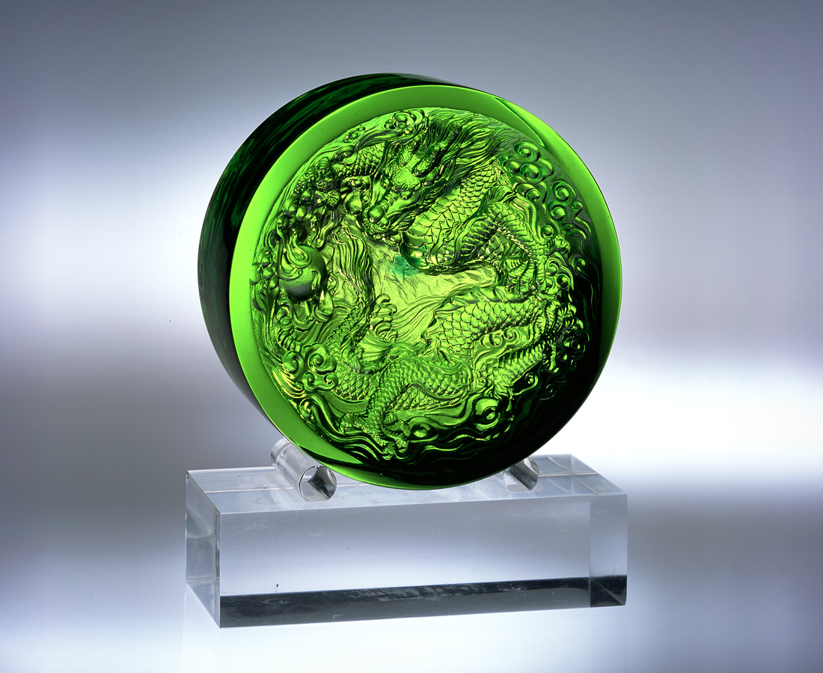
周延策劃 可潛可飛
靈活戰略 出神入化
廣結善緣 自在自得
精準落實 威勢八面
乘勝追擊 扭轉乾坤
謹守誠信 運勢如龍
Good Fortune Like a Dragon
Thorough planning; either swimming or flying A flexible strategy; performing uncanny feats Extensively reaping good affinities; at ease and satisfied Accurately fulfilling; earning influence and prestige Pressing home victory; turning the tide Guarding trustworthiness; with good fortune like a dragon

編號 | 1501013 | No | 1501013
名稱 | 運勢如龍 | Name | Good Fortune Like a Dragon
顏色 | 綠 | Color
尺寸 | 11.9 * 11.9 * 4.6 | Size | 11.9 * 11.9 * 4.6
重量 | 1.26 | Weight | 1.26
限量 | X | Limited Edition | X
售價 | NT$ 7888 | Price | NT$ 7888
 | RMB$ 1966 |  | RMB$ 1966

