故事 | 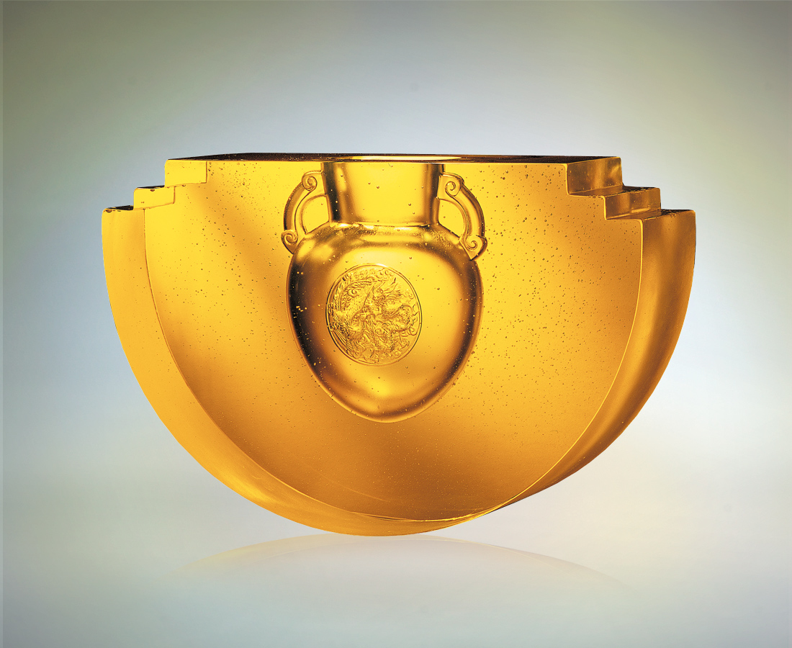
成龍之子 成鳳之女
是故事的核心
故事意喻宇宙與人生
虛實的節奏 強弱的分明
裡外的主張 陰陽的主從
舖陳整個情節的曲折
對比所張幟是和諧而非對立
是裡應外合 是剛柔並濟
是龍飛鳳舞 陰陽調和的
Story
The dragon men and phoenix women are the main cast of the story The story is about the universe and life Real and unreal rhythm. The distinction between strong and weak Internal and external viewpoints, and lord and servant yin-yang relationship Illustrate the twists and turns of the whole story Contrast shows harmony, not antagonism The co-ordination of within and without, the unity of strength and tenderness The dragon flies and the phoenix dance, yin-yang exist in harmony This is the story of China

編號 | 1457016 | No | 1457016
名稱 | 故事 | Name | Story
顏色 | 金 | Color
尺寸 | 11 * 38 * 24 | Size | 11 * 38 * 24
重量 | 29.0 | Weight | 29.0
限量 | O | Limited Edition | O
售價 | NT$ 138600 | Price | NT$ 138600
 | RMB$ 34660 |  | RMB$ 34660

