鼎立四方 | 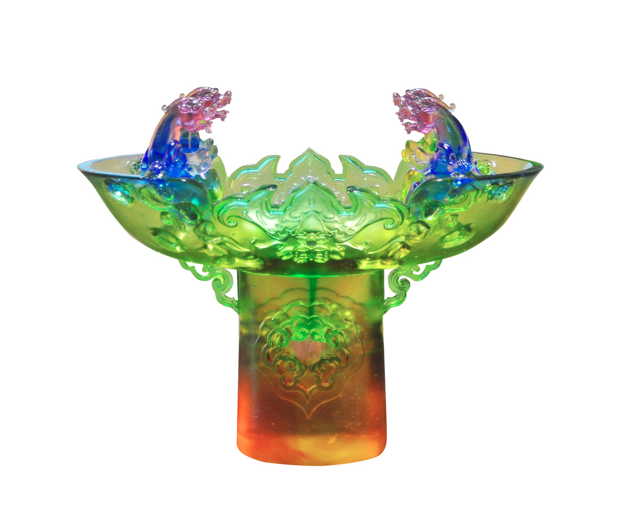
列鼎會中貴
鳴珂朝至尊
Ding and Pixiu
Tittot redesign Ding, the ancient Chinese cauldron, by adding the powerful Pixiu to represent the owner’s noble position.

編號 | 1443655 | No | 1443655
名稱 | 鼎立四方 | Name | Ding and Pixiu
顏色 | 藍紫綠琥透 | Color | blue, purple, green, amber, clear
尺寸 | 36 * 18 * 30 | Size | 36 * 18 * 30
重量 | 6.3 | Weight | 6.3
限量 | O | Limited Edition | O
售價 | NT$ 50550 | Price | NT$ 50550
 | RMB$ 11240 |  | RMB$ 11240

