開元 | 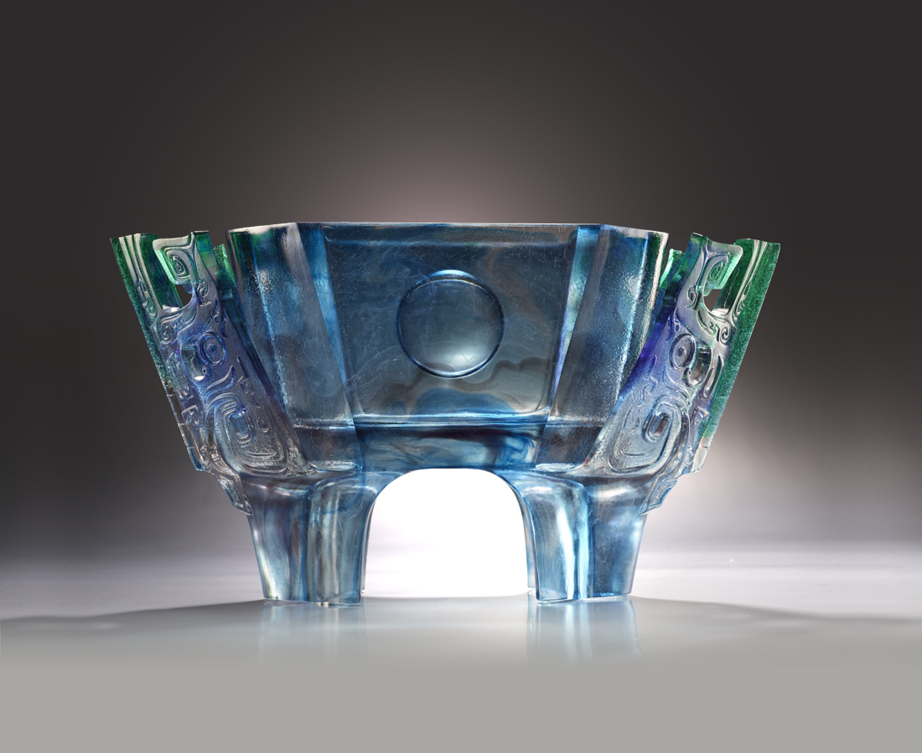
合掌 潛納磅礡
承古往風華
起身 撐開天地
立千年展望
New Era
Tittot has created this modern artwork on combining “Ding” and I Ching, which both are symbols of Chinese Culture This art piece symbolized a Ding held by two hands, conveying that 5000 years of Chinese history, and the descendants’ ambition to inherit it and glorified it.

編號 | 1443530 | No | 1443530
名稱 | 開元 | Name | New Era
顏色 | 藍綠青透 | Color | blue, green, cyan, clear
尺寸 | 45 * 12.5 * 25.5 | Size | 45 * 12.5 * 25.5
重量 | 10.5 | Weight | 10.5
限量 | O | Limited Edition | O
售價 | NT$ 118000 | Price | NT$ 118000
 | RMB$ 26200 |  | RMB$ 26200

