無往不利 | 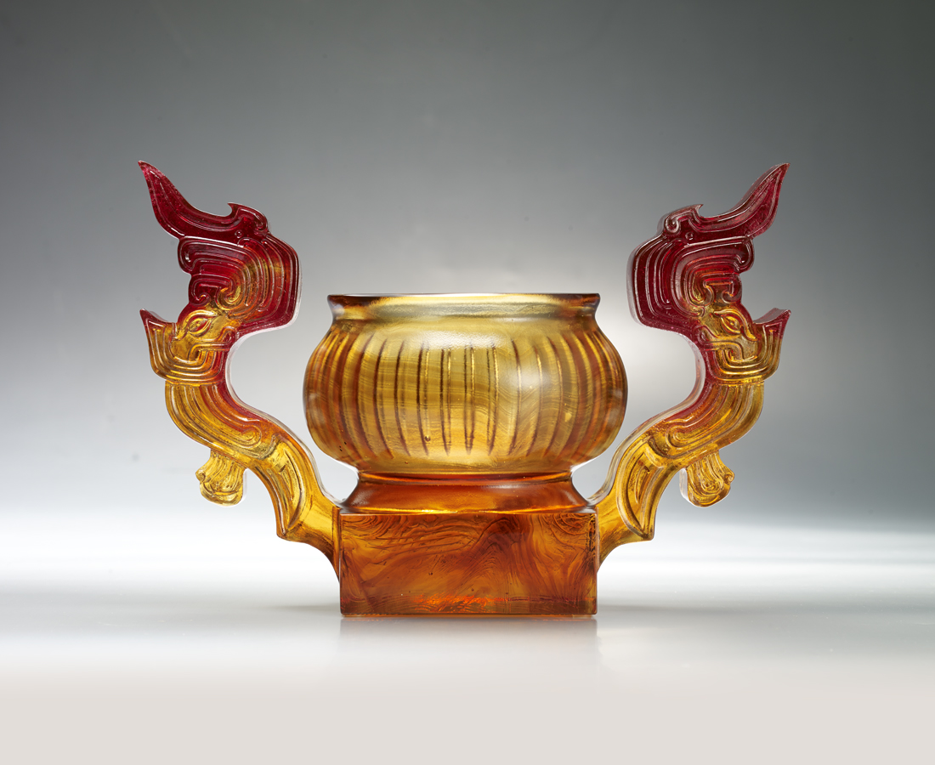
順勢而起
翱翔九霄之上
鸞鳳和鳴
能濟萬物群生
行遍天下 無往不利
The Ding of Soaring Up High
Tittot has created this modern artwork on combining “Ding” and I Ching, which both are symbols of Chinese Culture. The wide open wings of this art piece represent the progressive living attitude of the Chinese people.

編號 | 1443529 | No | 1443529
名稱 | 無往不利 | Name | The Ding of Soaring Up High
顏色 | 紅金琥透 | Color | red, golden, amber, clear
尺寸 | 24 * 13 * 16 | Size | 24 * 13 * 16
重量 | 3.0 | Weight | 3.0
限量 | O | Limited Edition | O
售價 | NT$ 23800 | Price | NT$ 23800
 | RMB$ 5290 |  | RMB$ 5290

