崛起 | 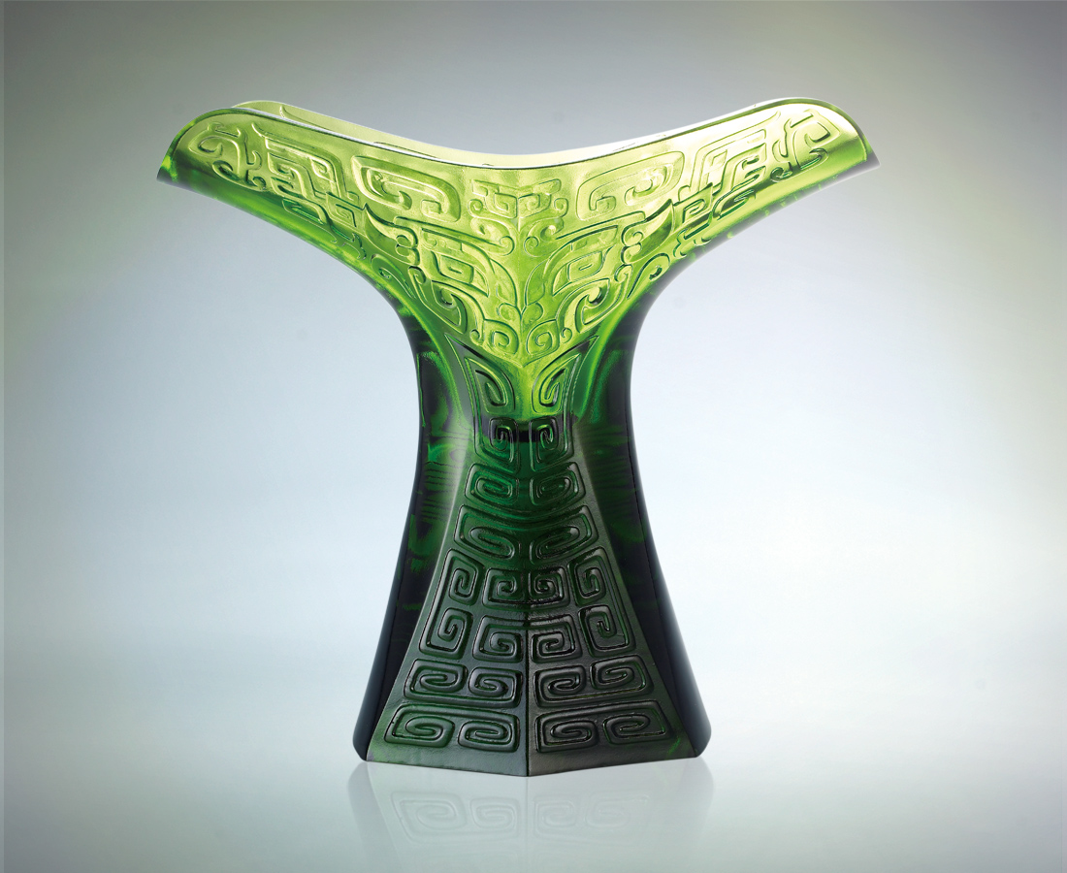
真誠忠己，
熱情炯炯，
迎萬千之變，
化無窮妙用，
而藝高崛起，
展翅高飛。
The Rise
With loyalty and honesty To yourself and an enthusiasm that never ends We transform the relentless tides of nature Into our numerous abilities And fly with our outstretched wings to rise To the realm of the finest art

編號 | 1443224 | No | 1443224
名稱 | 崛起 | Name | The Rise
顏色 | 綠 | Color
尺寸 | 11.8 * 28.4 * 25.8 | Size | 11.8 * 28.4 * 25.8
重量 | 4.8 | Weight | 4.8
限量 | O | Limited Edition | O
售價 | NT$ 32800 | Price | NT$ 32800
 | RMB$ 7280 |  | RMB$ 7280

