天地寬 | 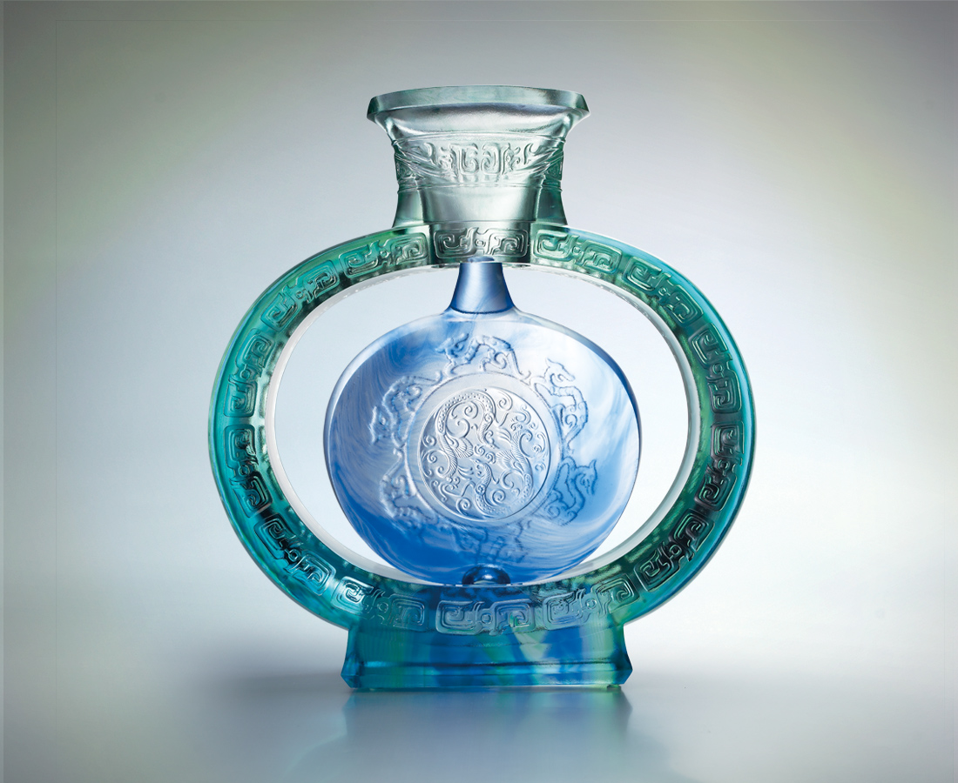
以圓融之心，
入圓滿之境，
一飛騰萬里，
一舞滿春風，
不勝暢然適意，
處處好時光。
The Enormous Sky and Earth
With a heart seeking for perfection, we enter its realm Our journey covers thousands of miles And our spirit is as bright as the spring breeze With free will, we live in happiness

編號 | 1443220 | No | 1443220
名稱 | 天地寬 | Name | The Enormous Sky and Earth
顏色 | 藍綠青透 | Color
尺寸 | 9.2 * 31 * 33 | Size | 9.2 * 31 * 33
重量 | 9.5 | Weight | 9.5
限量 | O | Limited Edition | O
售價 | NT$ 69800 | Price | NT$ 69800
 | RMB$ 15500 |  | RMB$ 15500

