將大任 | 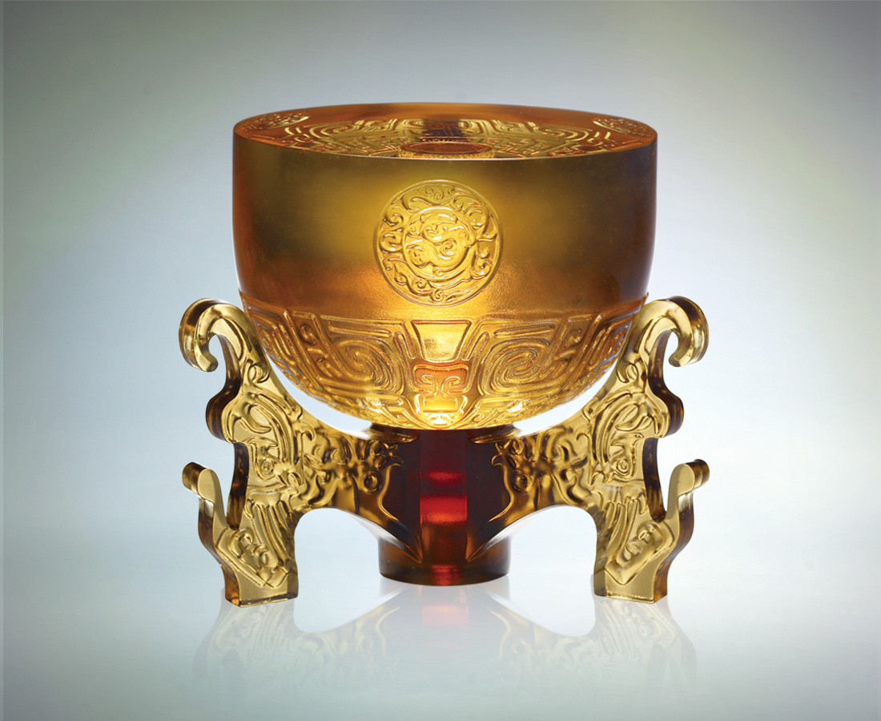
竭智，望風而動，自由自在；盡力，發揮所能，負重致遠。
有才有見識，有能有毅力，則任大事、立大業，富天下。
Take on Responsibilities
Exhaust the mind, move with the wind, be free at will. Spare no effort, utilize all power and take on responsibilities. With skills, knowledge, ability and perseverance, one will rise, achieve and prosper.

編號 | 1443167 | No | 1443167
名稱 | 將大任 | Name | Take on Responsibilities
顏色 | 下件:茶+上件:金 | Color | null
尺寸 | 17.3 * 17.3 * 15.7 | Size | 17.3 * 17.3 * 15.7
重量 | 5.0 | Weight | 5.0
限量 | X | Limited Edition | X
售價 | NT$ 32200 | Price | NT$ 32200
 | RMB$ 7150 |  | RMB$ 7150

