攻頂 | 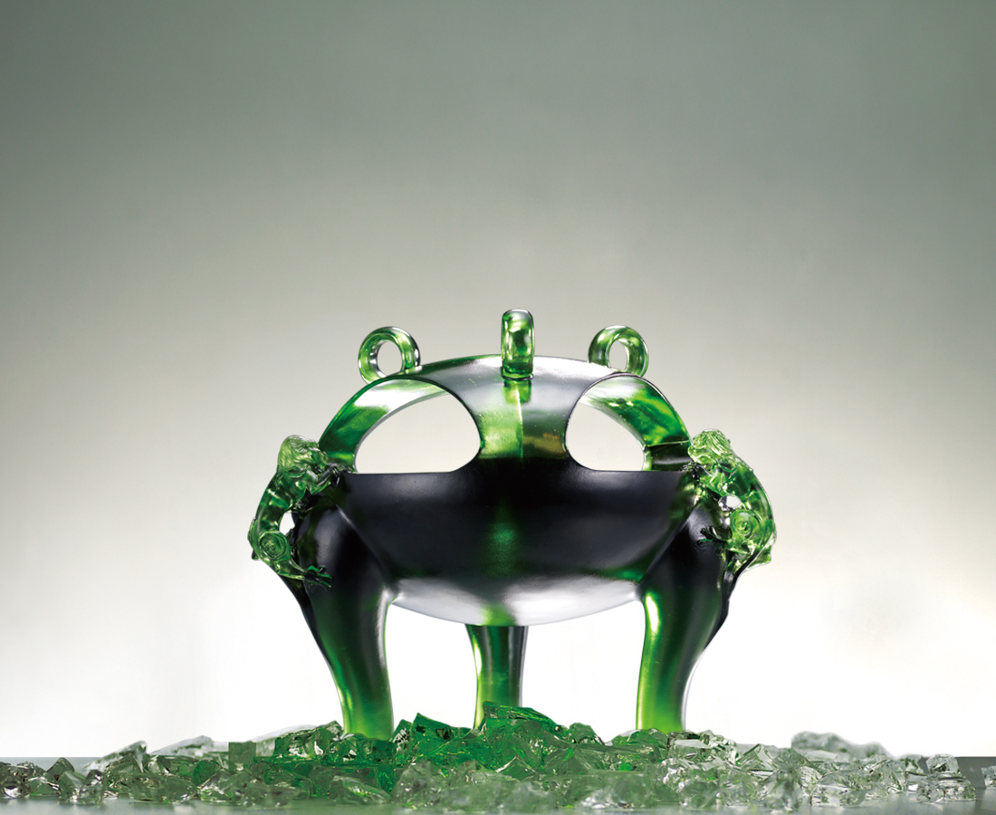
守堅毅信心，使氣力光燄，
敢為天下先，敢闖雄關道，
而步步追高，攻鼎掠地，拔頭籌。
The Treasure Hunt
In faith, courage stands. In blaze, strength bursts. With boldness to prevail, with bravery to venture, step by step we climb the tripod, claiming the award atop.

編號 | 1443166 | No | 1443166
名稱 | 攻頂 | Name | The Treasure Hunt
顏色 | 綠+金球 | Color
尺寸 | 29.2 * 28.1 * 25.1 | Size | 29.2 * 28.1 * 25.1
重量 | 16.0 | Weight | 16.0
限量 | O | Limited Edition | O
售價 | NT$ 126000 | Price | NT$ 126000
 | RMB$ 28000 |  | RMB$ 28000

