爵鼎尊榮 | 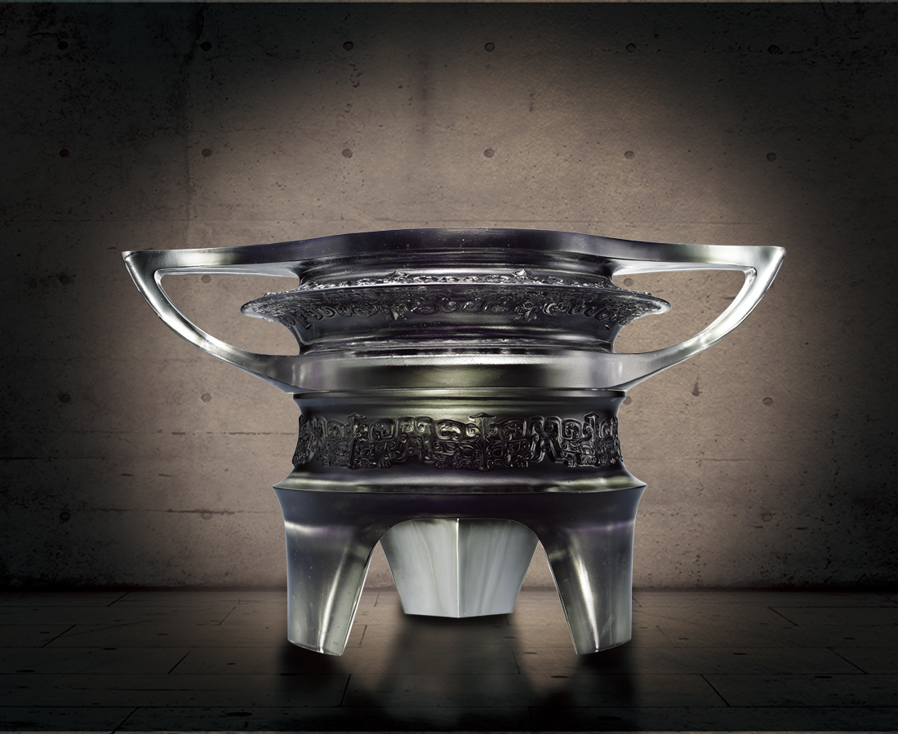
堂堂風範，如天地之廣闊，山海之高深；
能洞察遙遠，而言出九鼎、氣吞萬裏，揮就大功大業，永屹立。
Honorable Duke Ding
A dignified demeanor As broad as heaven and earth As high as the mountains and as deep as the sea Farsighted Speaks profound words Wields great undertakings Being remembered forever

編號 | 1443164 | No | 1443164
名稱 | 爵鼎尊榮 | Name | Honorable Duke Ding
顏色 | 灰透 | Color | null
尺寸 | 28.2 * 44 * 25.7 | Size | 28.2 * 44 * 25.7
重量 | 22.7 | Weight | 22.7
限量 | O | Limited Edition | O
售價 | NT$ 148000 | Price | NT$ 148000
 | RMB$ 32880 |  | RMB$ 32880

