立功業 | 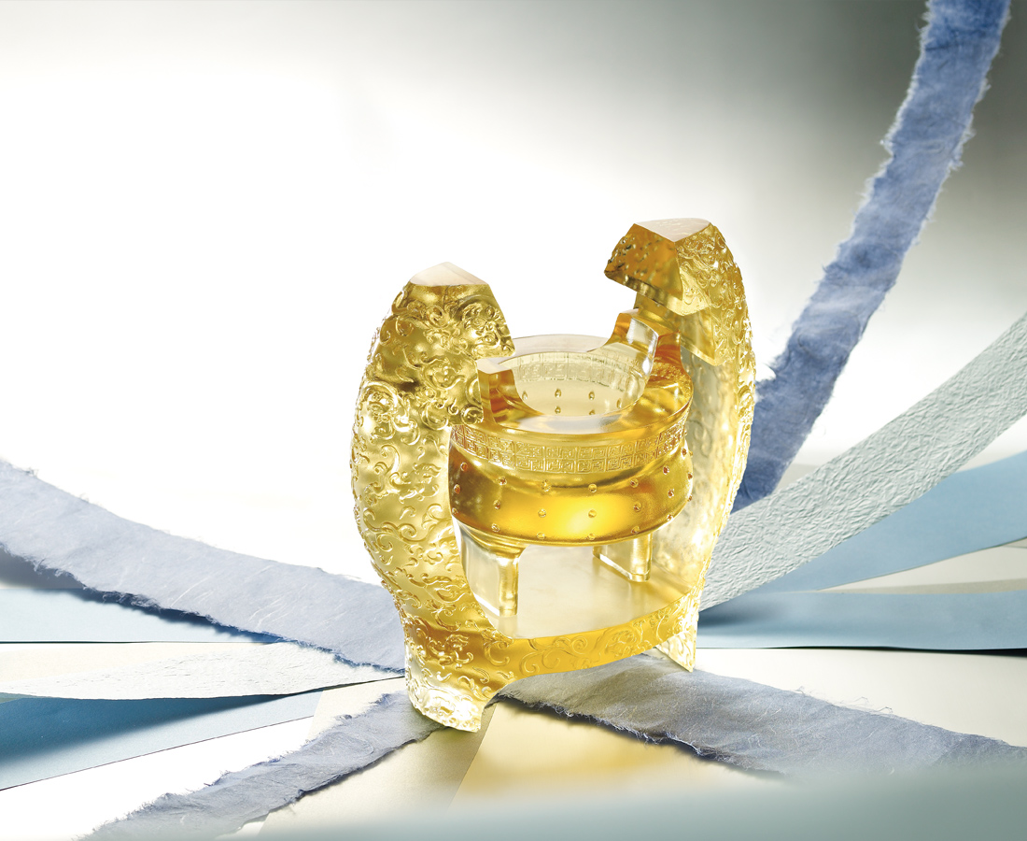
唯神龍，能乘雲而飛、駕霧以遨；
借勢使力、神變無窮，而立功建業、爵祿級級高陞，臨天下。
Attaining Accomplishments
Only the holy dragon can ride the cloud and mist to soar above the skies Capitalizing on it strength and advantages Greatness and success shall be guaranteed As though being on top of the world

編號 | 1443148 | No | 1443148
名稱 | 立功業 | Name | Attaining Accomplishments
顏色 | 金 | Color
尺寸 | 11.7 * 20.7 * 19.9 | Size | 11.7 * 20.7 * 19.9
重量 | 3.5 | Weight | 3.5
限量 | X | Limited Edition | X
售價 | NT$ 28800 | Price | NT$ 28800
 | RMB$ 6400 |  | RMB$ 6400

