集大成 | 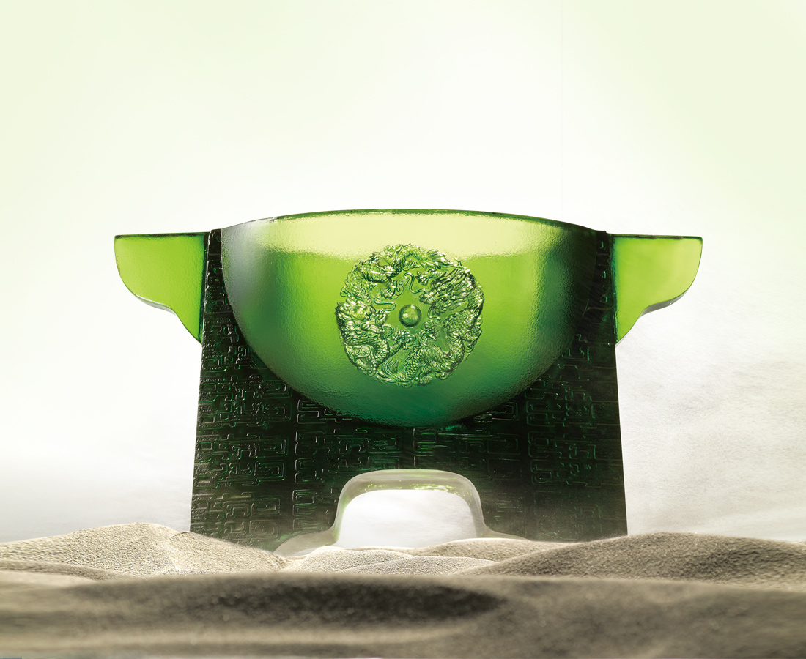
盡己之能、集眾之力、參天地之智；
精實才藝、精鍊武技，而剛強不摧、氣魄豪壯，霸天下。
Culmination of Greatness
Perform your best, gather the strength of all the people As well as the wisdom of the Heaven and Earth Refine your skills and martial arts Become indestructible, daring and heroic Dominate the world

編號 | 1443147 | No | 1443147
名稱 | 集大成 | Name | Culmination of Greatness
顏色 | 綠 | Color
尺寸 | 15 * 26.8 * 17.2 | Size | 15 * 26.8 * 17.2
重量 | 5.4 | Weight | 5.4
限量 | X | Limited Edition | X
售價 | NT$ 31800 | Price | NT$ 31800
 | RMB$ 7060 |  | RMB$ 7060

