和合盈 | 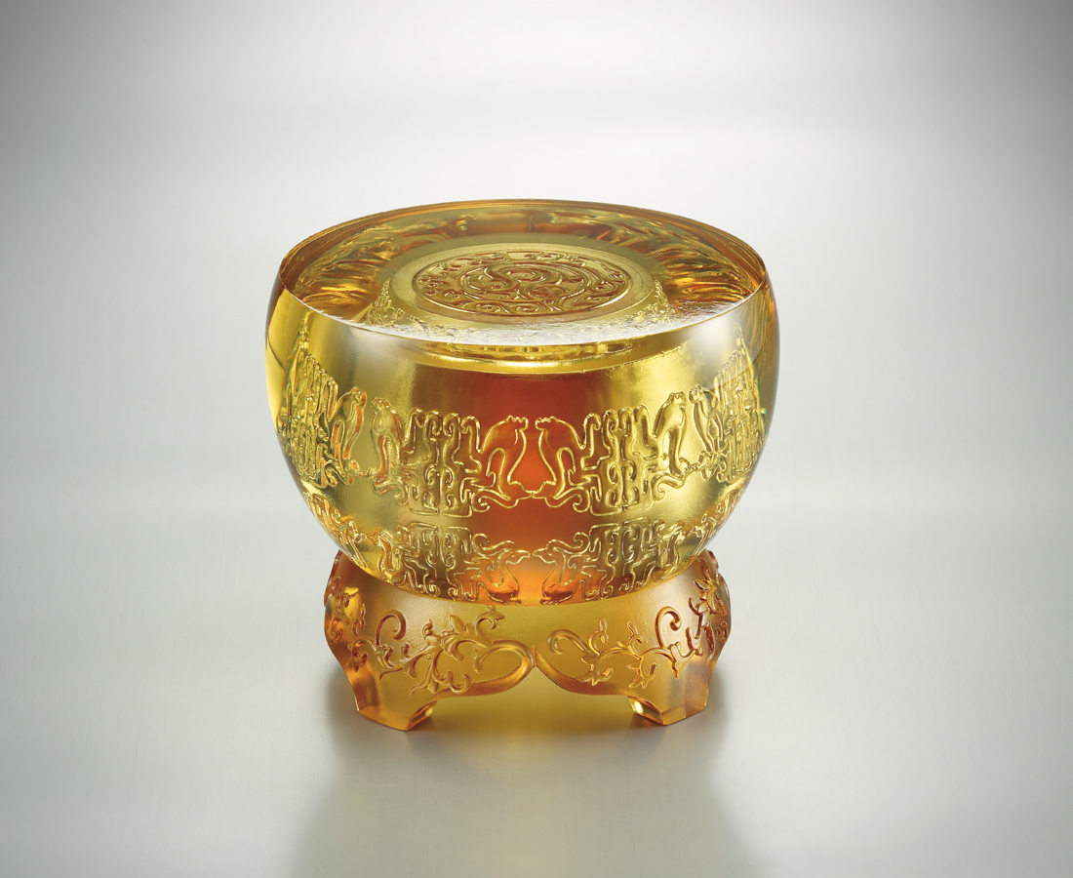
擇良木而棲，飛九重青天；順陰陽之化，生萬物興旺。
抱理想行事、持自然之道，而進退有節、圓融無礙，得天下。

Perfect Harmony
Perch on the sturdiest branch, soar high into the skies The harmony between the Yin and the Yang All things in the Universe thrive with prosperity Act upon the ideals and obey the course of nature Advance and retreat accordingly Be smooth all round, and the world shall be within your grasp

編號 | 1443144 | No | 1443144
名稱 | 和合盈 | Name | Perfect Harmony
顏色 | 上件:金+下件:琥 | Color | null
尺寸 | 12.6 * 12.6 * 10.6 | Size | 12.6 * 12.6 * 10.6
重量 | 2.2 | Weight | 2.2
限量 | X | Limited Edition | X
售價 | NT$ 13850 | Price | NT$ 13850
 | RMB$ 3050 |  | RMB$ 3050

