坐擁高祿 | 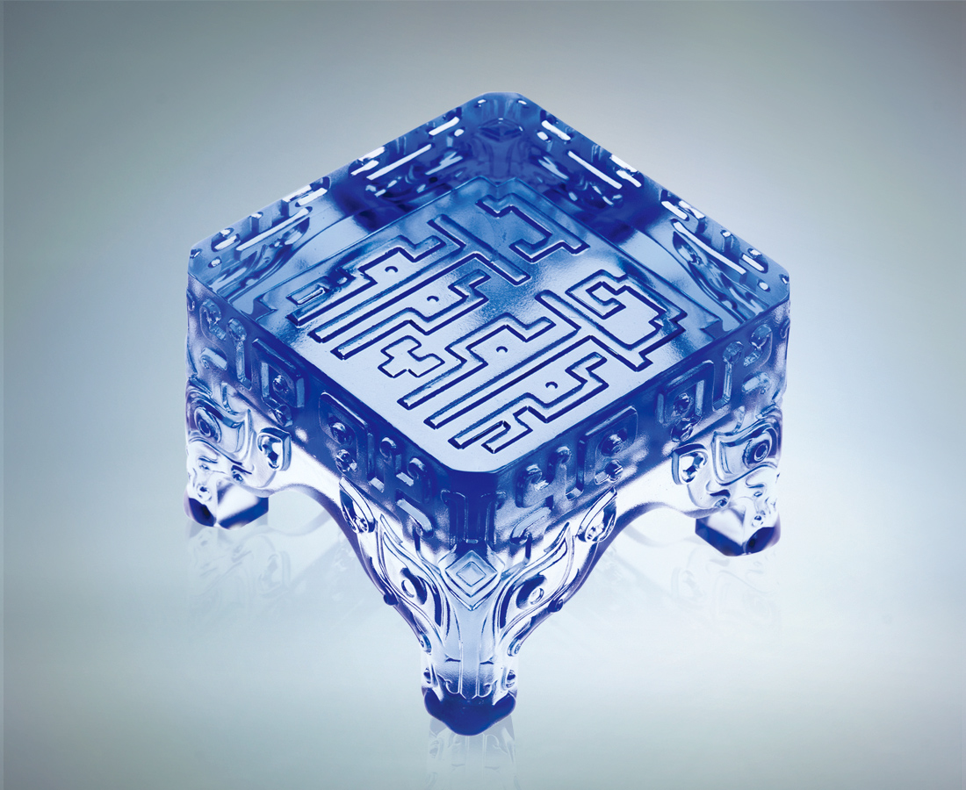
瞪炯炯之眼
燃火熱之心
處事情 精準快 客觀專業
觀世界 情理法 溫馨公正
嚴以律己 寬以待人
一身 立足方正不阿
一世 坐擁福慧高祿
The Seat of Power
Fiery gaze of passionate heart Analyze minutia with laser precision Perceive grandeur with lucid compassion Bestow generosity on others while reserving discipline for the self. The self shall stand with unwavering dignity The life shall enjoy the fortune of wisdom and luxury.

編號 | 1442306 | No | 1442306
名稱 | 坐擁高祿 | Name | The Seat of Power
顏色 | 藍 | Color
尺寸 | 8 * 8 * 5.6 | Size | 8 * 8 * 5.6
重量 | 0.63 | Weight | 0.63
限量 | X | Limited Edition | X
售價 | NT$ 4680 | Price | NT$ 4680
 | RMB$ 1166 |  | RMB$ 1166

